**SPLUNK**

**Splunk Beginner to Architect**

**Section 5: Forwarder & User Management:**

1. **Overview of Universal Forwarder:**

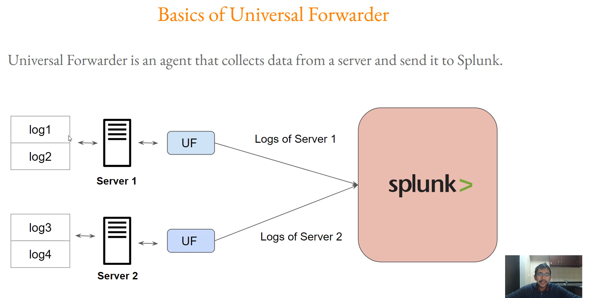

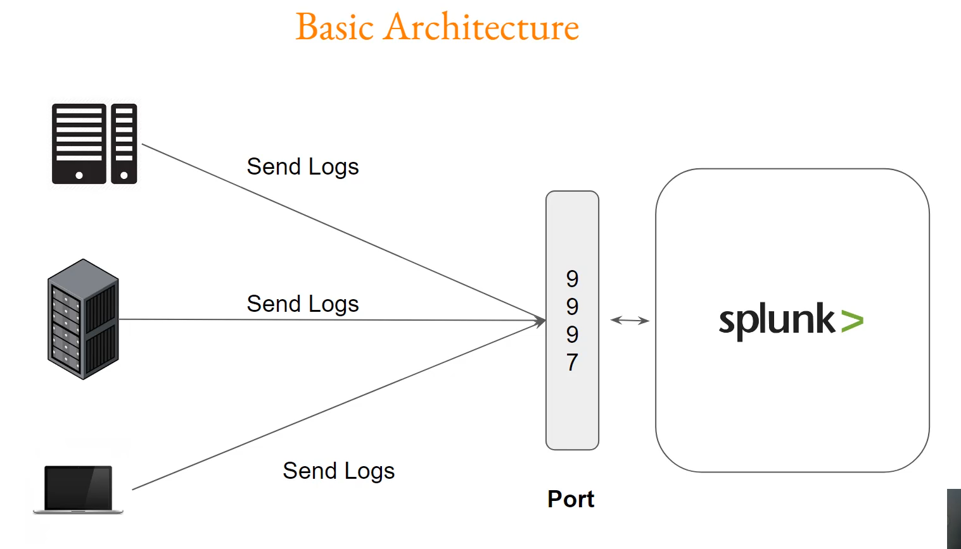

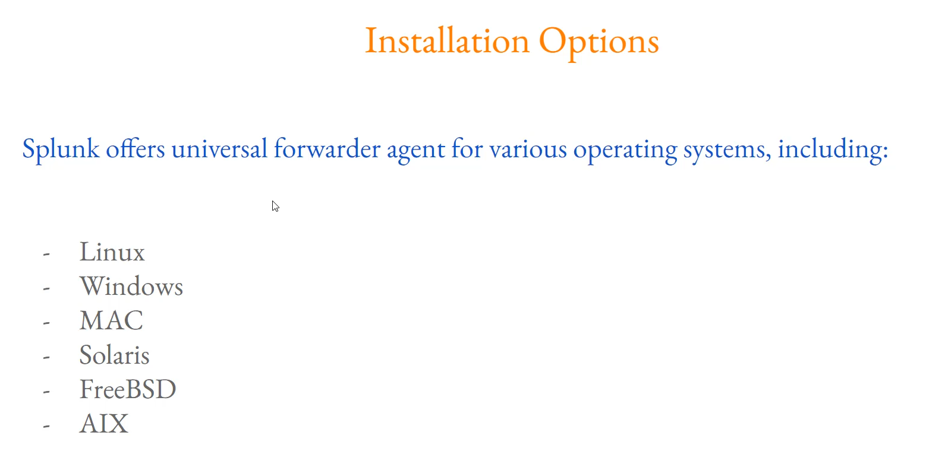

**Splunk Universal Forwarder Summary**

**1. Core Definition and Purpose**

* **Definition:** The Splunk **Universal Forwarder (UF)** is a lightweight **agent** that must be installed on remote devices (servers, laptops, etc.).
* **Purpose:** Its primary function is to **collect data/logs** from these devices and reliably **send (forward)** that data to a central Splunk instance for indexing and searching.
* **Necessity:** This agent is required whenever logs need to be sent from distributed sources (like user laptops or application servers) to the central Splunk platform.

**2. Architectural Overview**

* **Setup:** You install the Universal Forwarder agent on various devices (Servers 1, 2, Laptops, etc.).
* **Data Flow:** The UF agent actively monitors and collects log files from the device.
* **Central Instance:** The agent then sends these collected logs to the central Splunk instance (the Indexer).
* **Receiving Port:** The central Splunk instance is configured to receive all incoming forwarded data on a specific **receiving port**, typically **9997**. Once received on this port, the logs are indexed by Splunk.

**3. Key Management and Operation Points**

* **Log Collection Example:** The demonstration showed a UF collecting common Linux log files like auth.log and cloud-init-output.log from the server and sending them to the central Splunk instance.
* **Host Identification:** In the central Splunk instance, the forwarded data is easily identifiable by the **Host** name (e.g., "Splunk forwarder") in the data summary.
* **Operational Importance:** The Universal Forwarder is one of the most **critical components** in a Splunk environment that administrators will actively manage and troubleshoot to ensure **all appropriate log files** are being forwarded correctly.
* **Broad Compatibility:** The Universal Forwarder is widely supported across many major operating systems, including:
  + Linux
  + Windows
  + Mac OS
  + Solaris

===================================================================================

1. **Installing Universal Forwarder in Linux:**

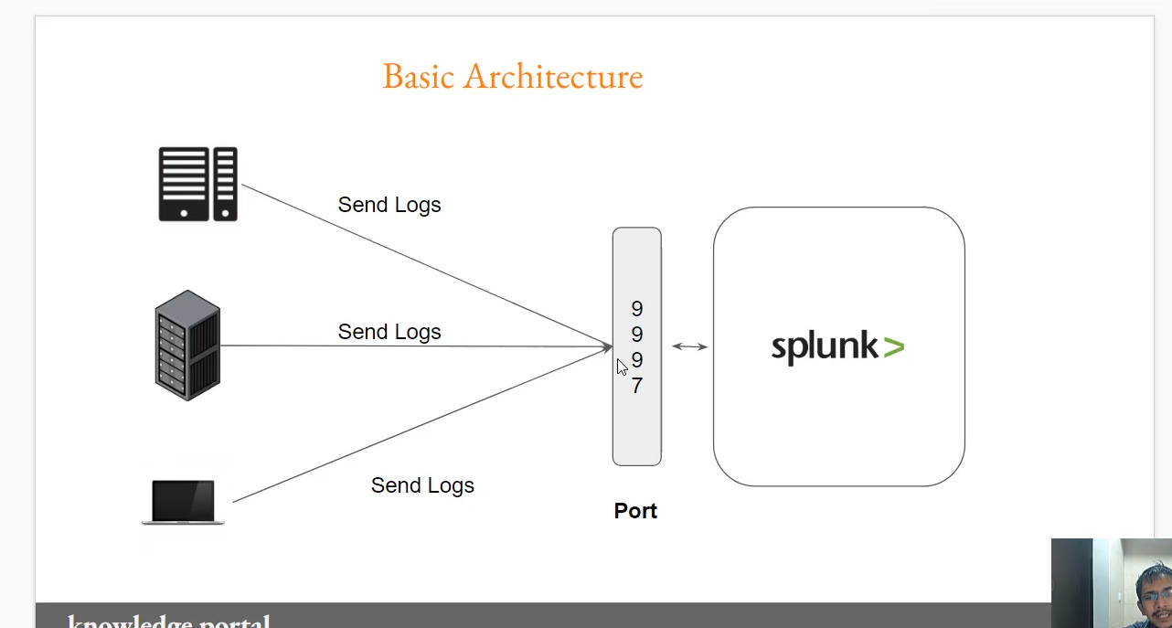

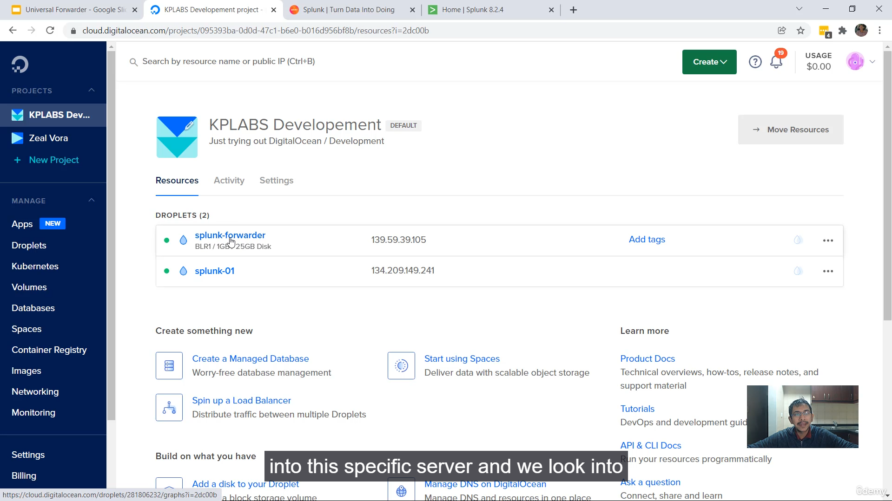

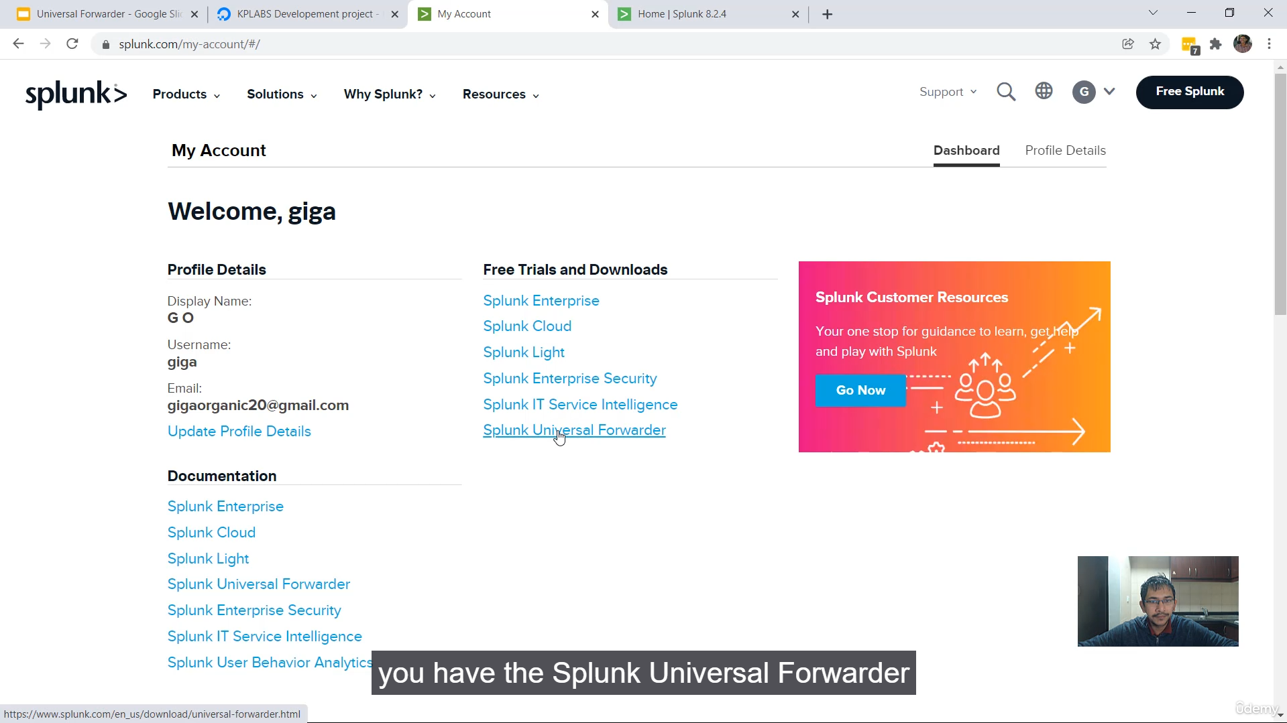

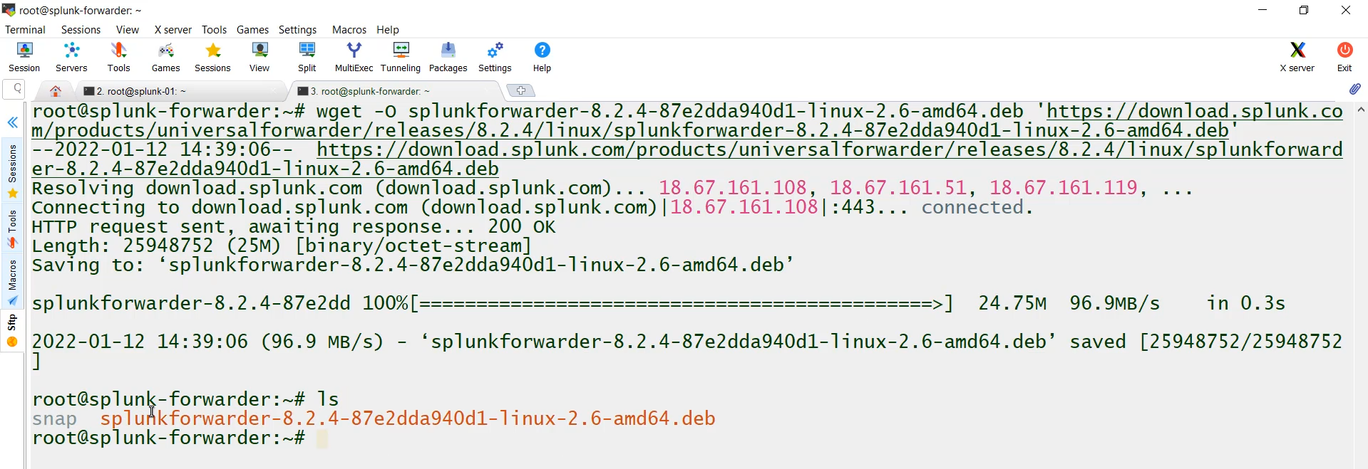

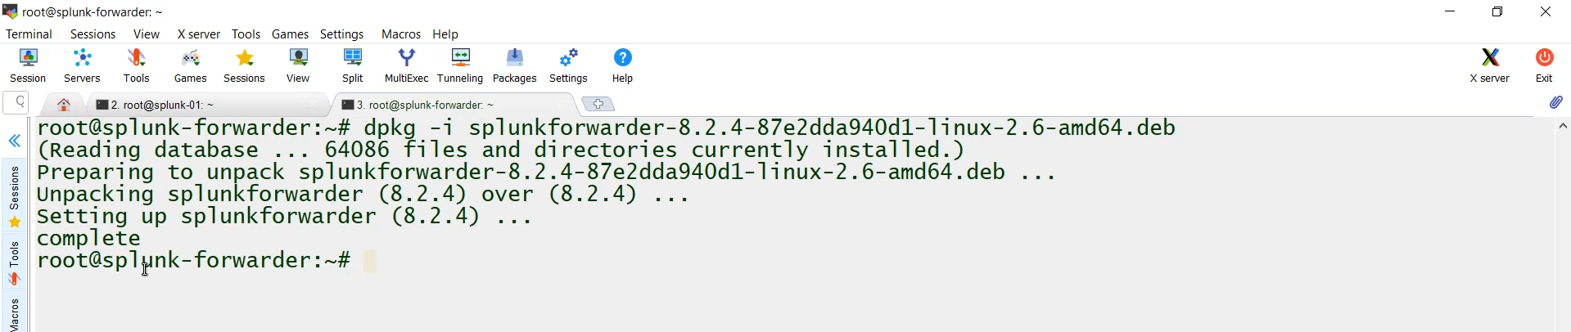

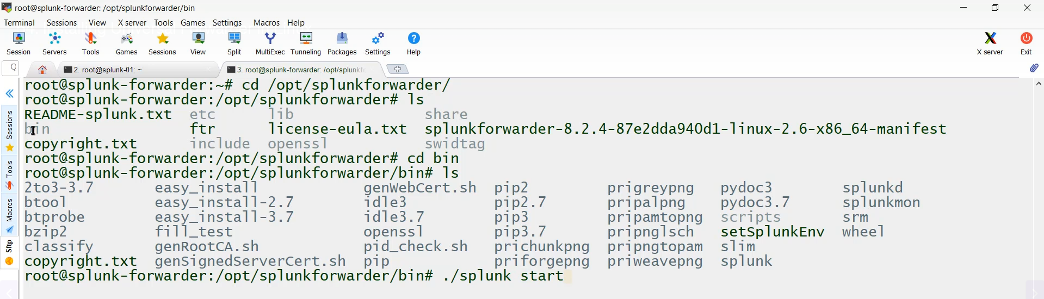

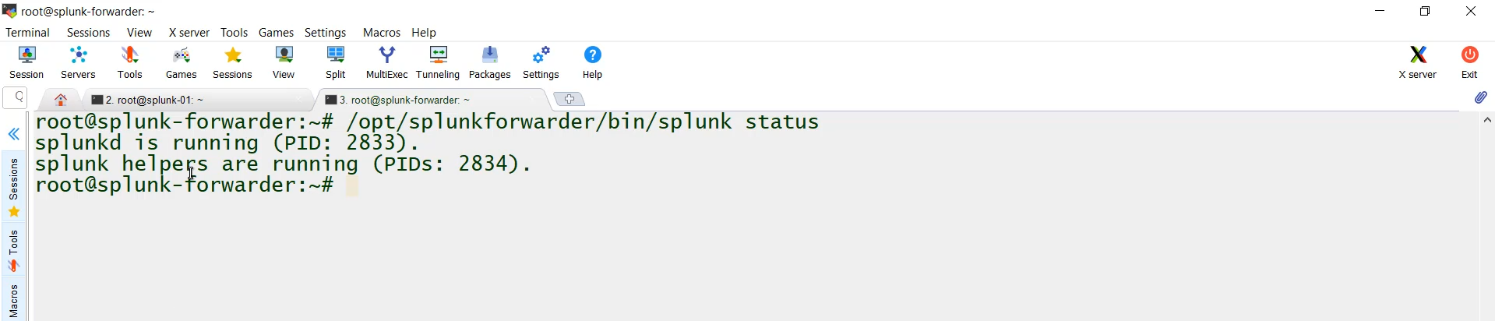

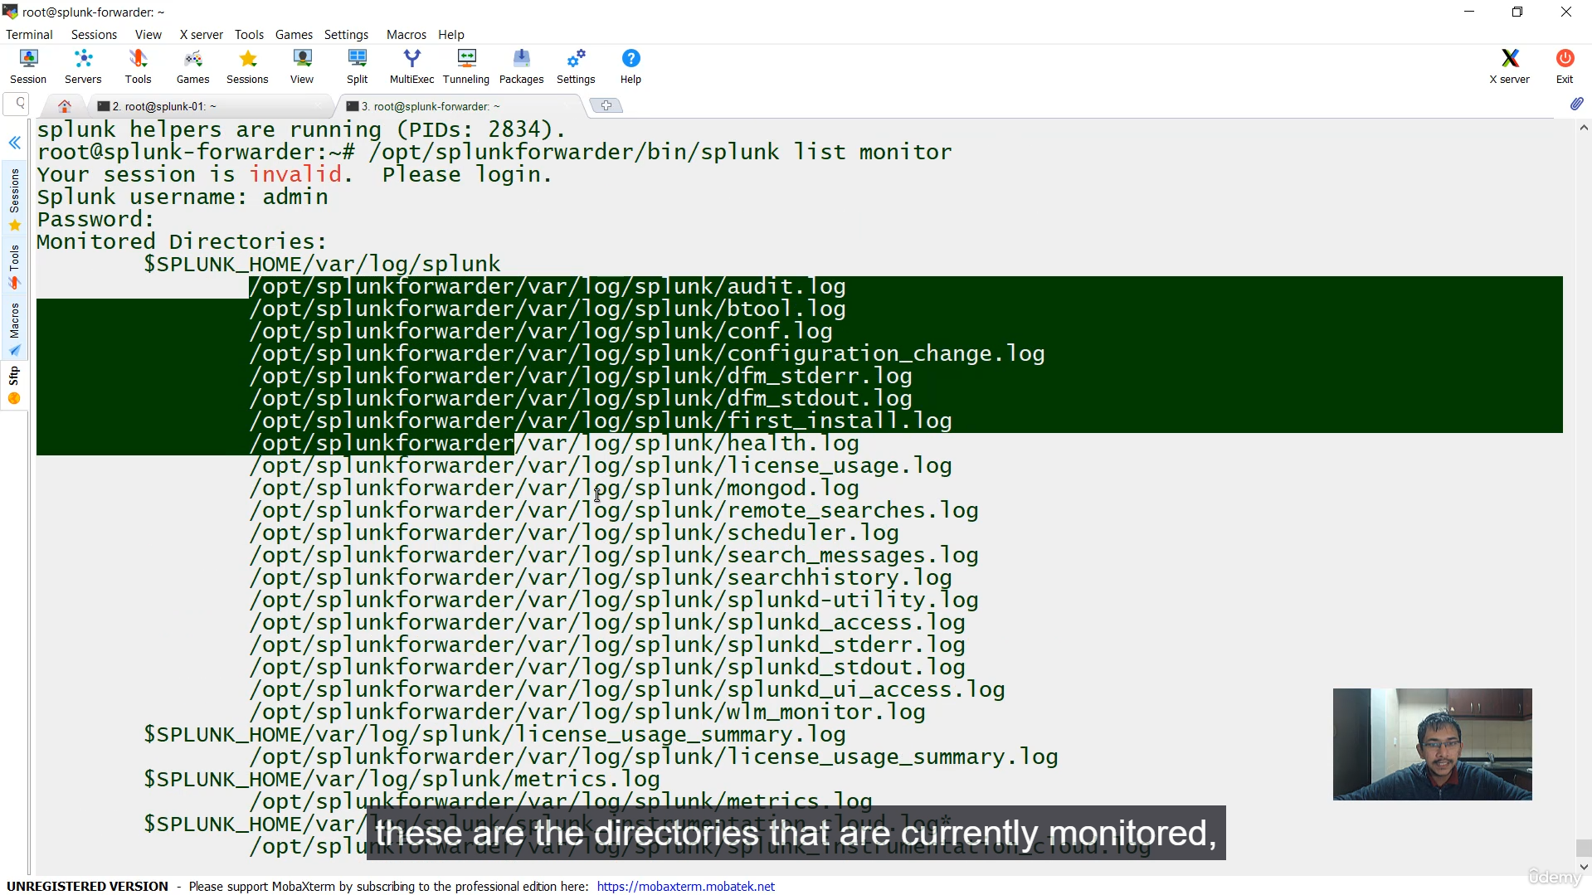

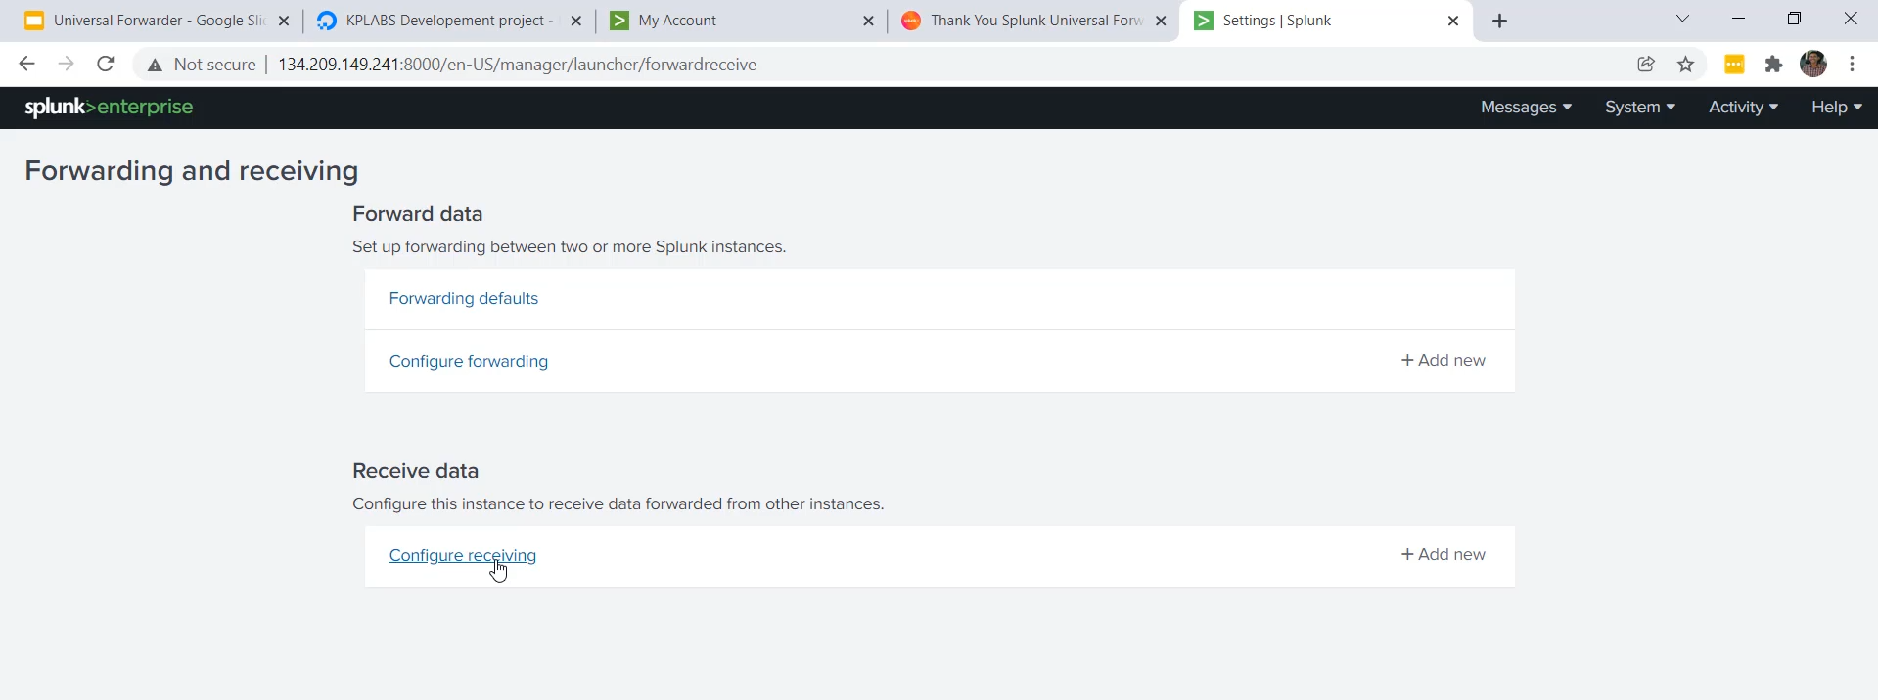

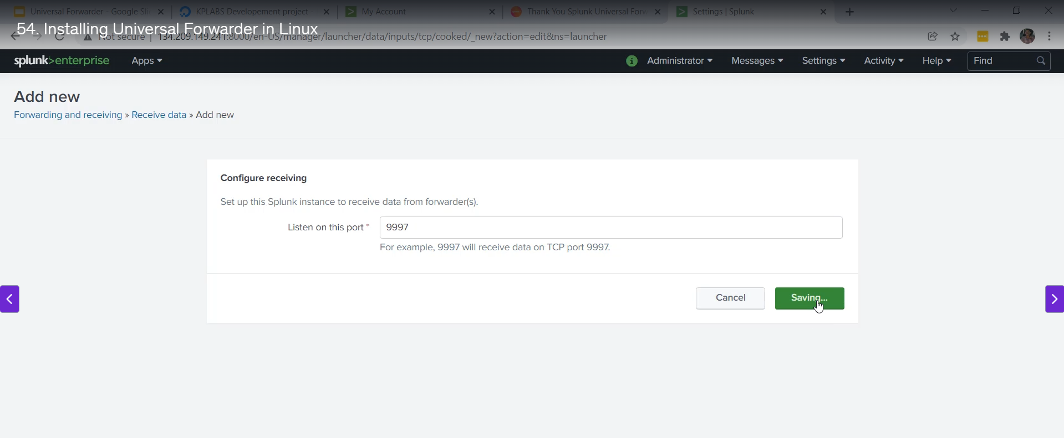

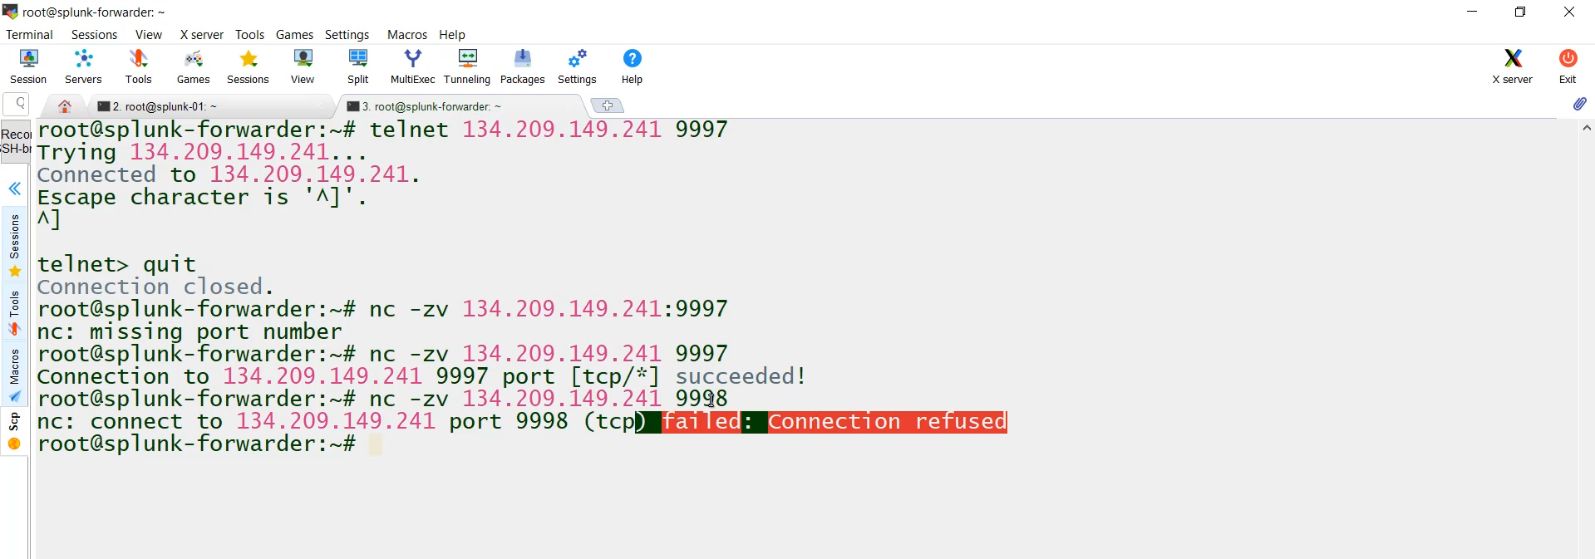  
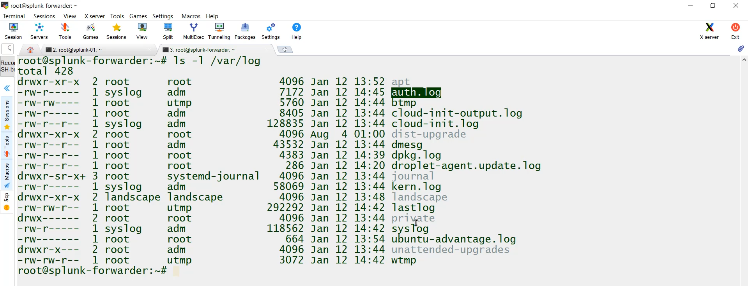

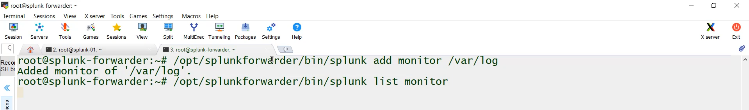

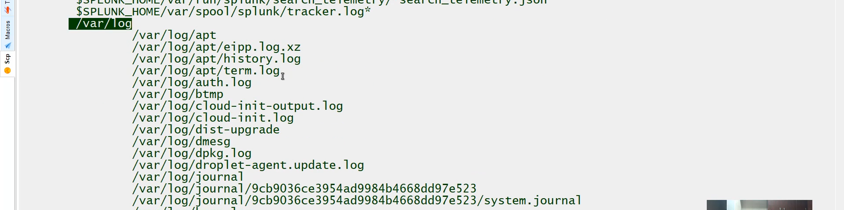

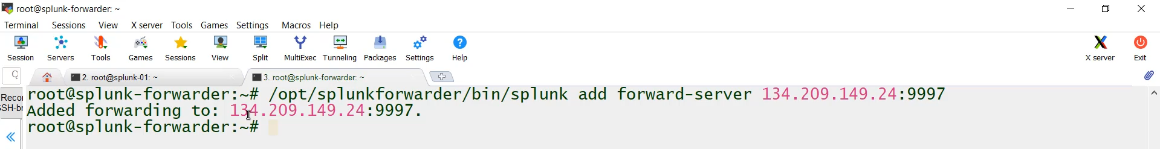

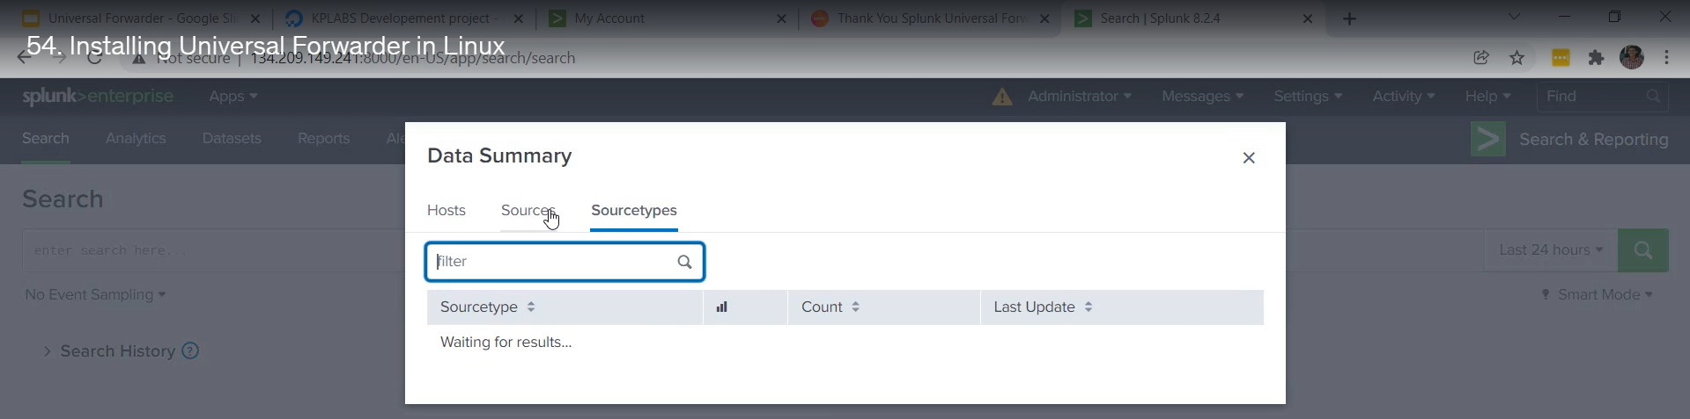



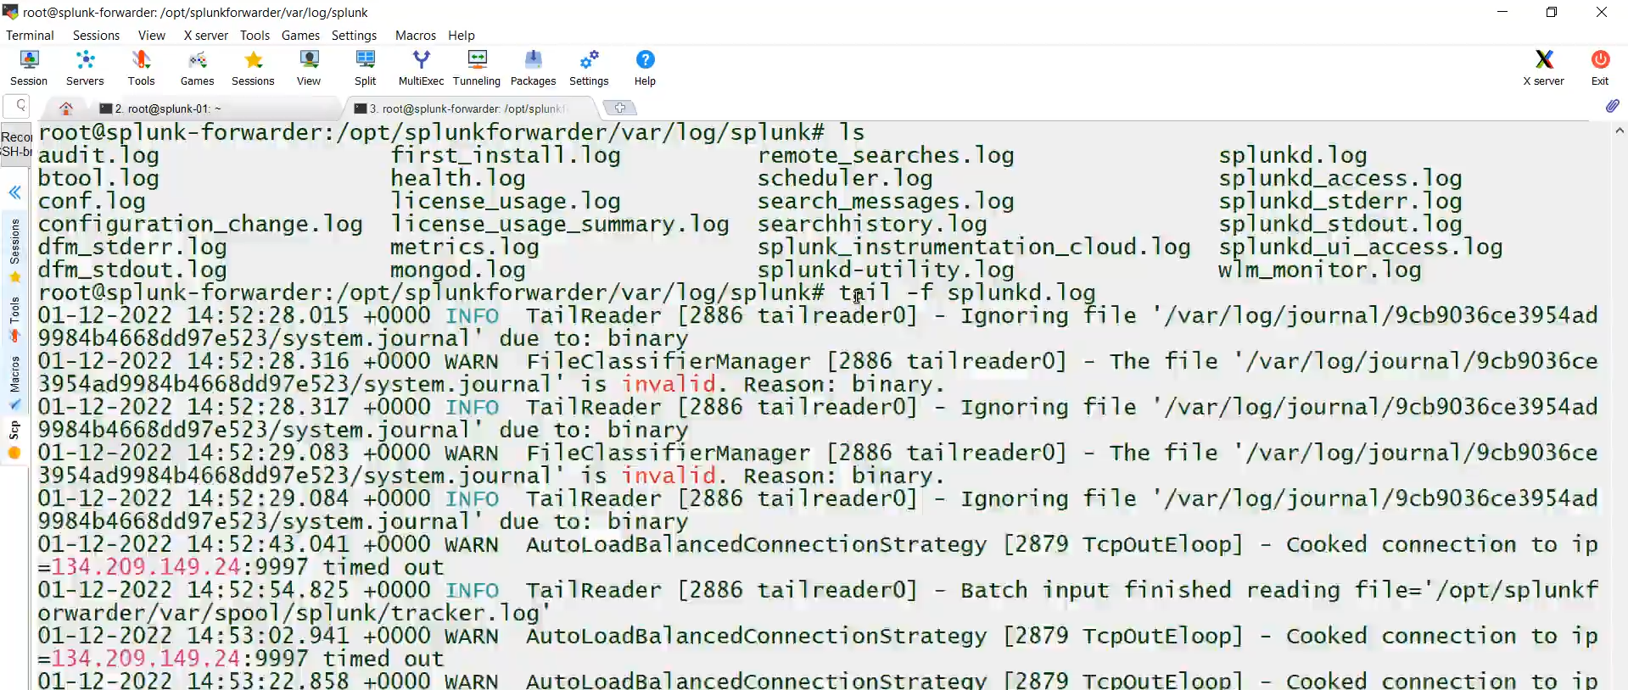

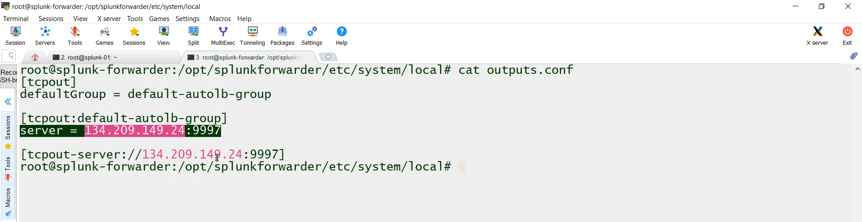

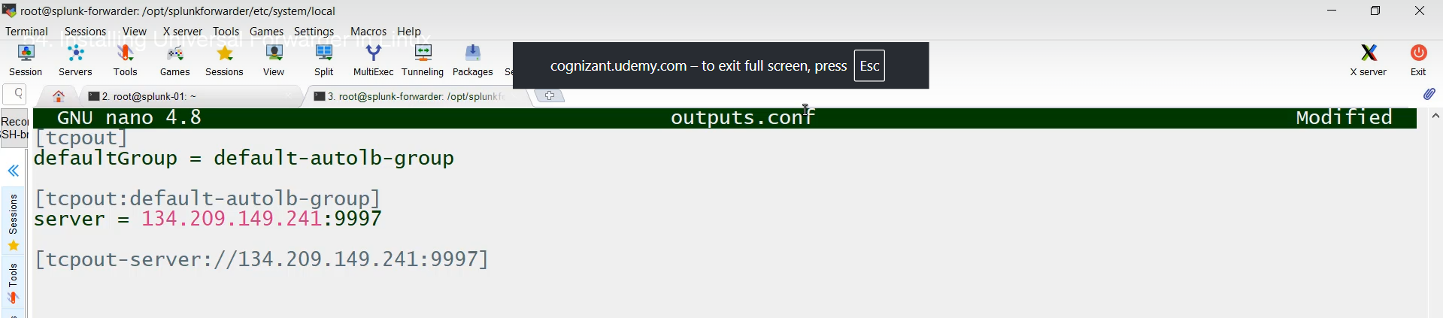

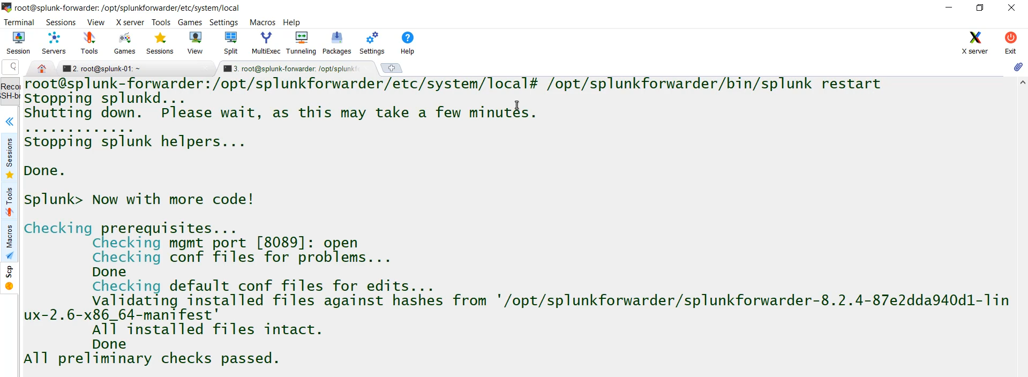

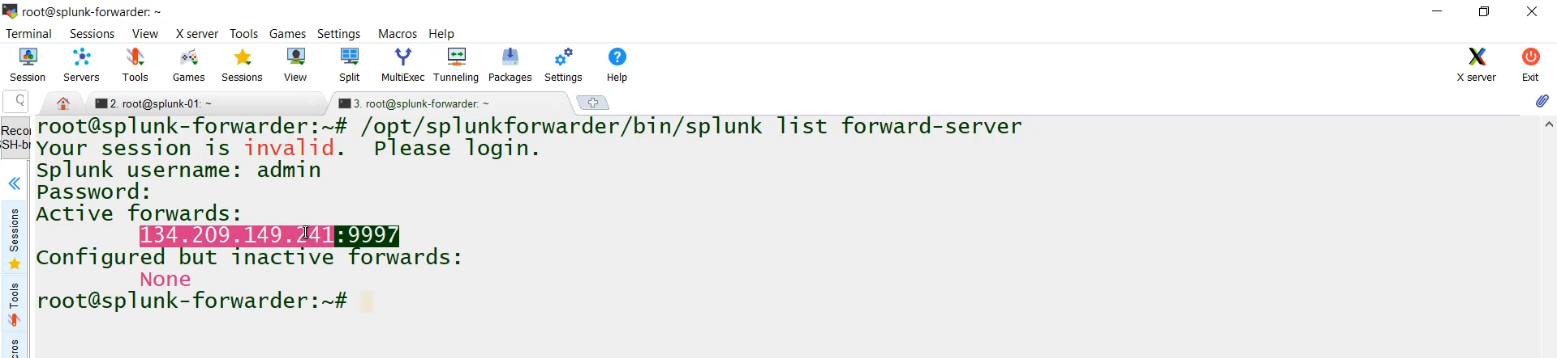

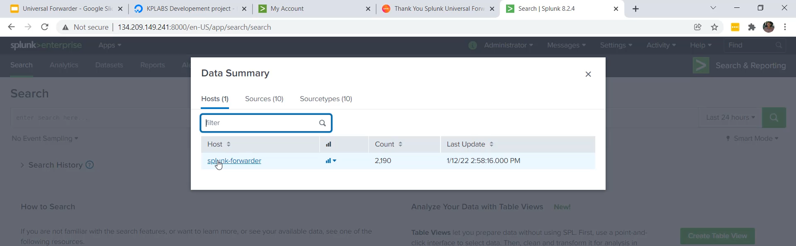

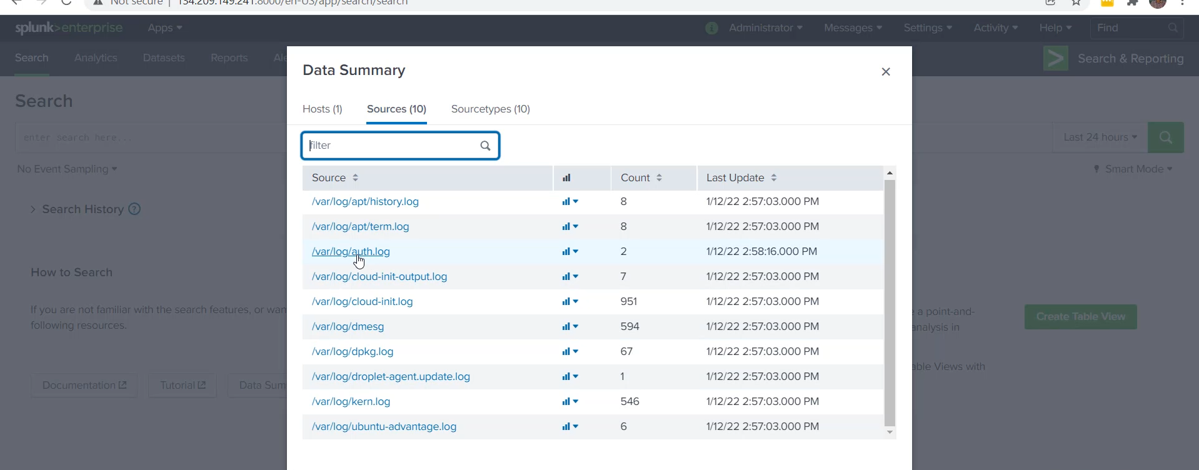

**Universal Forwarder Installation and Configuration Summary**

**1. Prerequisites and Setup**

* **Two Components Needed:**
  1. **Central Splunk Instance (Indexer):** The server that will receive and index the logs (e.g., Splunk-01).
  2. **Test Server (Forwarder):** A server where the UF will be installed to collect and send logs (e.g., Splunk-Forwarder).
* **Downloading the Agent:** The Universal Forwarder agent is downloaded from the Splunk website (Trials and Downloads section).
  1. The correct package must be selected based on the OS (e.g., **Deb** for Ubuntu, **RPM** for Red Hat/CentOS/Rocky Linux).

**2. Universal Forwarder Installation (Forwarder Server)**

1. **Download:** Use the wget command to download the .deb or .rpm file.
2. **Install:** Run the package installer command (e.g., dpkg -i <filename.deb>).
3. **Start and Configure:**
   * Navigate to the binary path: OPT/Splunkforwarder/bin.
   * Start the UF: Run ./splunk start.
   * Accept the license agreement and set the username/password.
4. **Verification:** Check the status: ./splunk status (should show "Splunk is running").
   * Check default monitored directories (audit logs, internal UF logs) using: ./splunk list monitor.

**3. Indexer Configuration (Receiving Logs)**

The central Splunk instance must be configured to open a listening port:

1. **Access Settings:** Go to **Settings** $\rightarrow$ **Forwarding and Receiving**.
2. **Add Receiving Port:** Click **"New Receiving Port"**.
3. **Specify Port:** Enter the default receiving port: **9997** and click **Save**.

**4. Connectivity Check (Troubleshooting)**

Before configuring the forwarder to send data, verify network connectivity:

* **Tool:** Use utilities like telnet or netcat (nc -z) from the **Forwarder Server** to the **Indexer's IP address** on port 9997.
* **Goal:** The command must report a successful connection (Connected or succeeded); otherwise, the connection will fail (often due to a firewall).

**5. Forwarder Configuration (Sending Logs)**

1. **Configure Monitoring Inputs:** Tell the UF which logs to collect (e.g., system logs):
   * Command: ./splunk add monitor /var/log
   * *Note:* The command is run from OPT/Splunkforwarder/bin.
2. **Configure Forwarding Server:** Tell the UF the destination (Indexer IP and port):
   * Command: ./splunk add forward-server <Indexer IP>:9997
3. **Restart:** Restart the UF for changes to take effect: ./splunk restart

**6. Troubleshooting and Verification (Crucial Step)**

If logs don't appear in the Indexer after setup:

* **Check the Log File:** The most important file for UF troubleshooting is **splunkd.log** located at OPT/Splunkforwarder/var/log/splunk/.
* **Identify Errors:** Check the tail of splunkd.log for errors (e.g., "timing out" or "failed to connect").
* **Fixing Configuration (e.g., IP Typo):** If an error is found (like a typo in the IP address), the settings can be manually corrected in the configuration file:
  + File Path: OPT/Splunkforwarder/etc/system/local/outputs.conf.
  + Modify the IP address under the [tcpout] stanza.
  + Restart the UF after modification.
* **Final Verification:** After a successful connection log entry ("connected to IDX") is seen in splunkd.log, search the central Splunk instance. You should now see logs indexed under the new **Host** name (Splunk-Forwarder) and the new **Sources** (files from /var/log).

**Log File for any Troubleshooting:**

tail -f /opt/splunkforwarder/var/log/splunk/splunkd.log

**Configuration File Referenced in the video:**

cat /opt/splunkforwarder/etc/system/local/outputs.conf

===================================================================================

**3. Overview of Agent Management:**

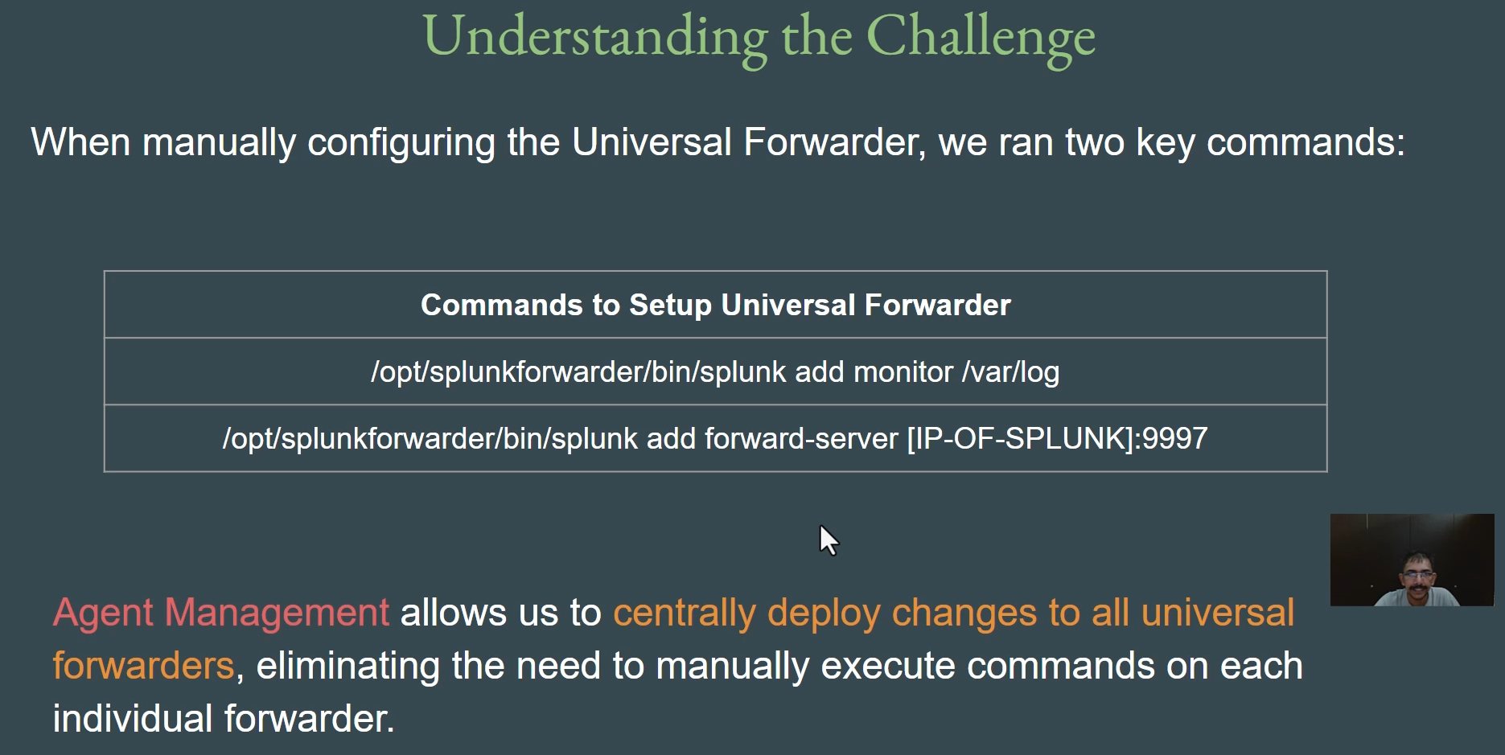

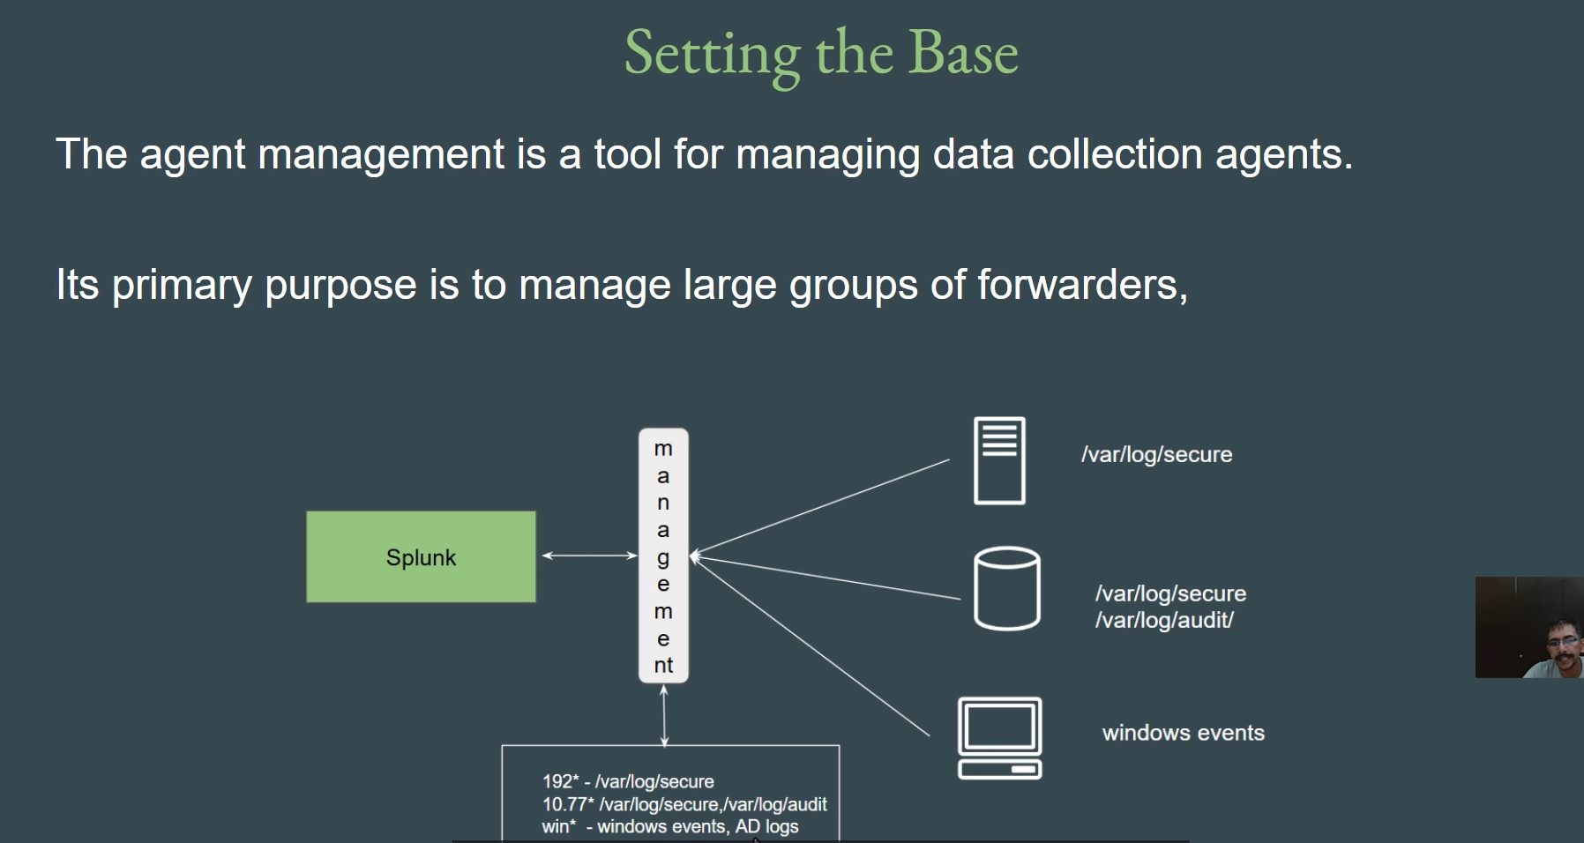

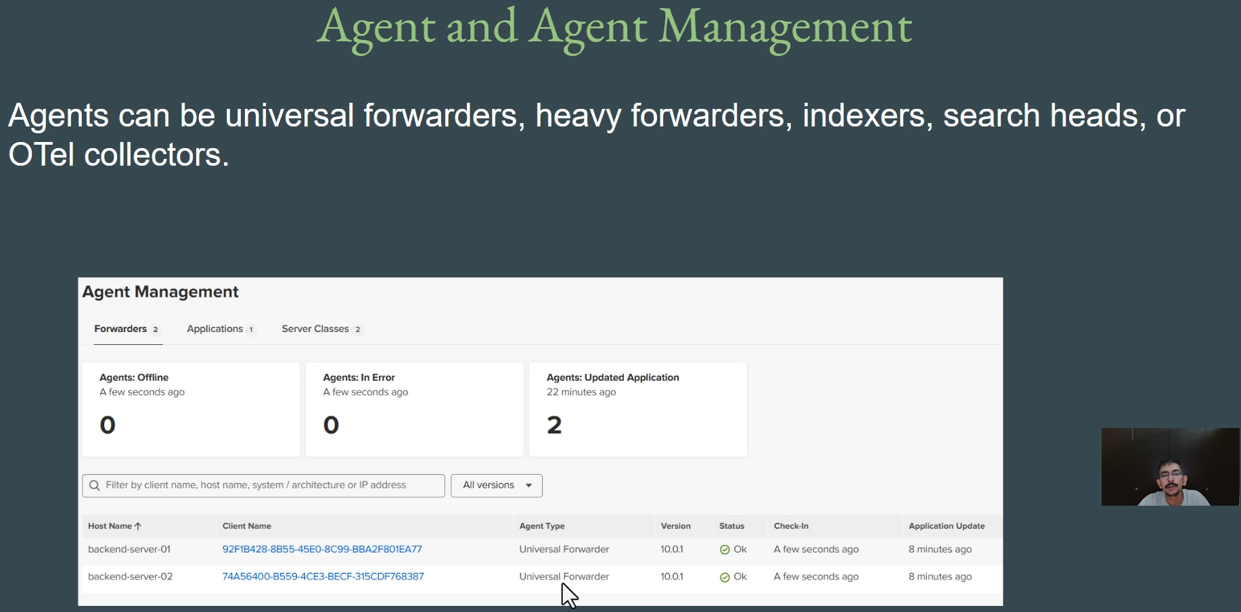

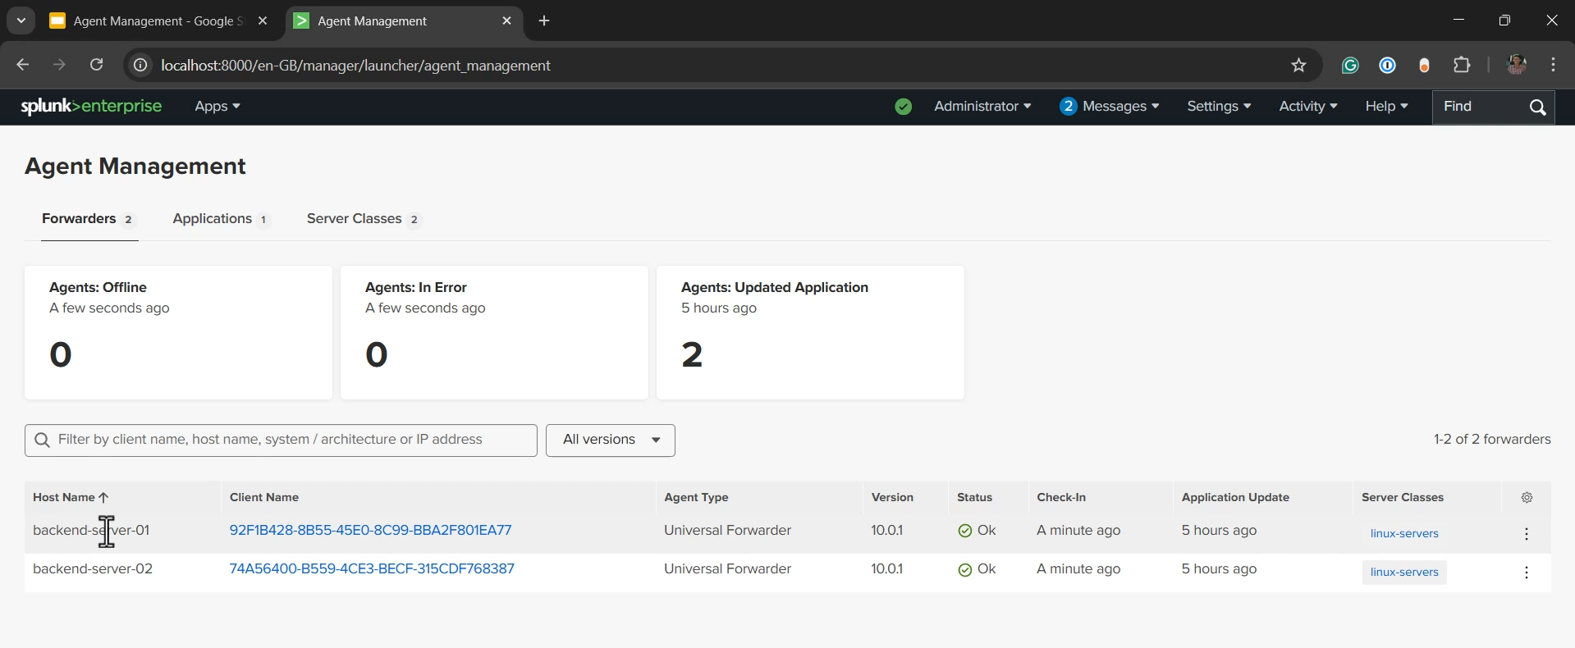

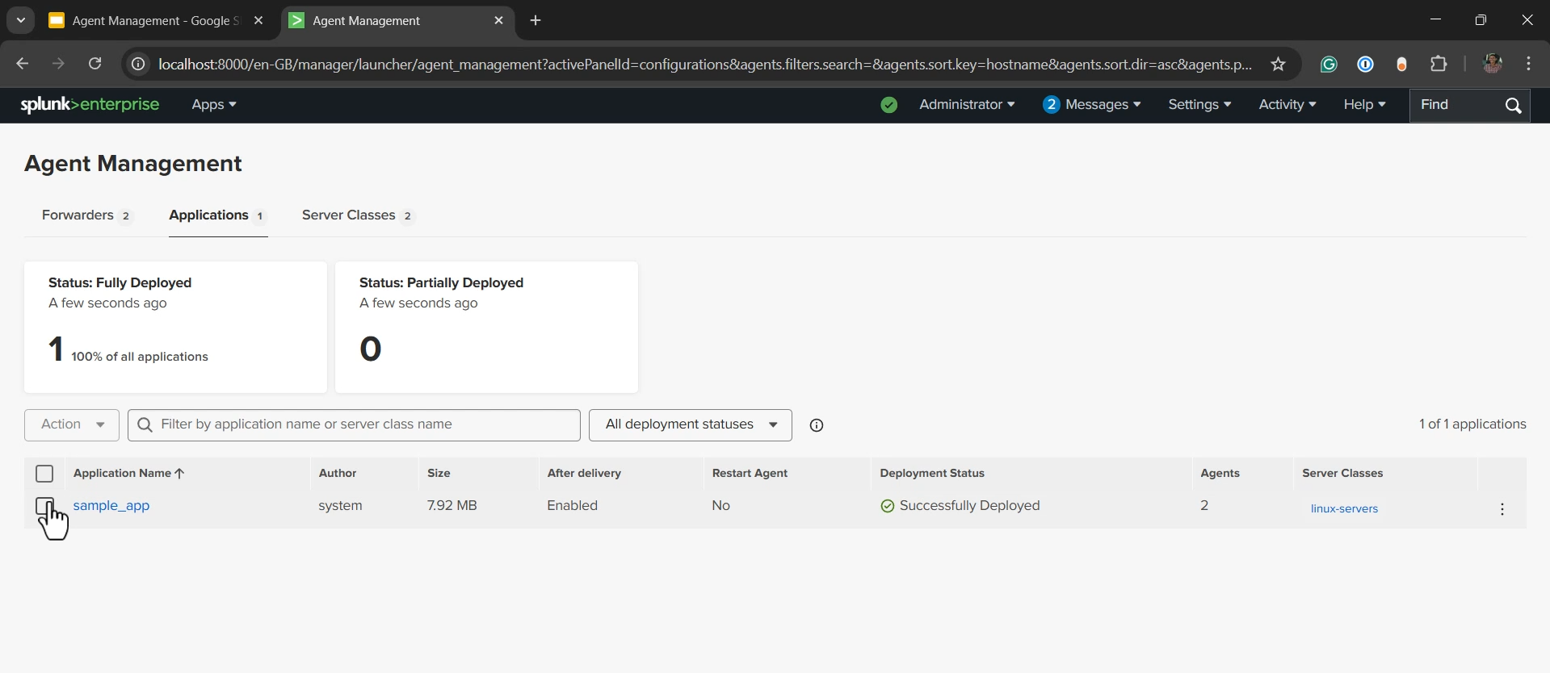

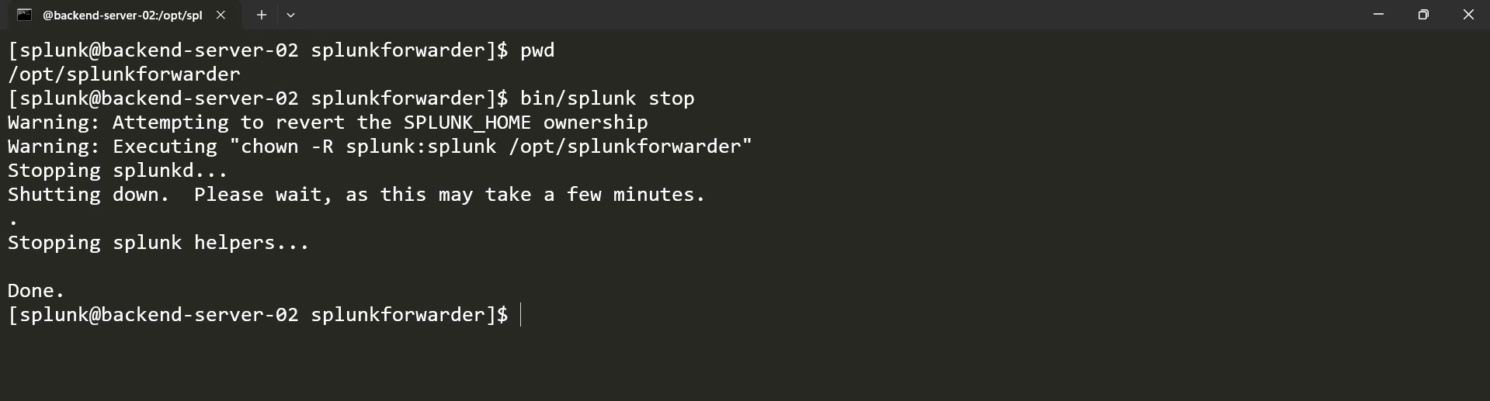

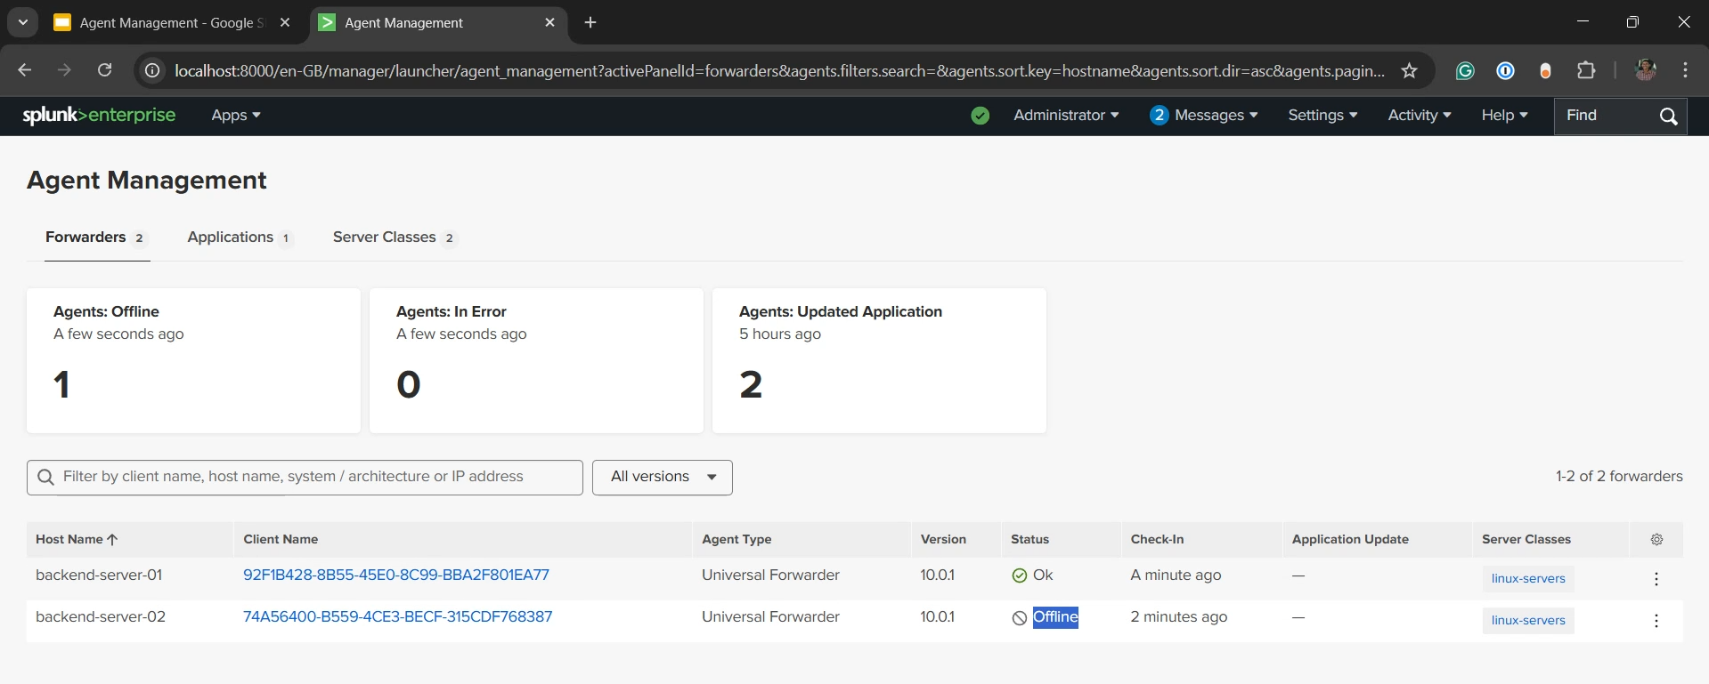

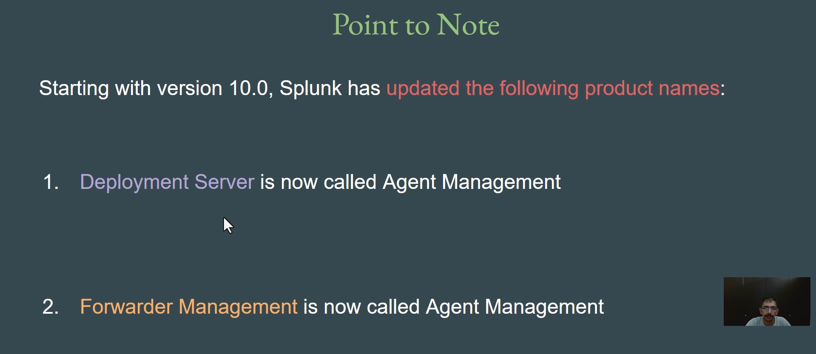

**Splunk Agent Management Summary**

The video introduces **Agent Management** as the superior, centralized solution for deploying configuration changes to a large number of Universal Forwarders (or other agents), overcoming the challenges of manual or decentralized automation.

**1. The Challenge with Traditional Forwarder Management**

* **Initial Setup is Manageable:** Installing the Universal Forwarder (UF) and running initial commands (like add monitor for 1$\text{var/log}$ and add forward-server) can be automated once (e.g., via Ansible, Chef, Puppet).2
* **The Scaling Problem:** In large enterprises with thousands of servers, introducing a **new log file** to monitor requires:
  + Creating and deploying a new automation script (Ansible playbook, etc.) to **all thousands of servers** for *each and every* configuration change.
* **Conclusion:** This repetitive, decentralized approach is inefficient and not the best practice for managing frequent configuration updates across a huge fleet of forwarders.

**2. Splunk Agent Management Overview**

* **Goal:** To allow **centralized deployment** of configuration changes to all Universal Forwarders (and other agents), eliminating the need for automation tools to run commands on every single endpoint.
* **Central Feature:** The feature acts as a central control plane within the Splunk environment.3
* **Mechanism:** You configure the changes once in the central Splunk instance, and the Agent Management feature automatically distributes and applies these changes to the connected forwarders.4

**3. Architecture and Capabilities**

* **Primary Purpose:** Managing large groups of data collection agents.
* **Agents Supported:** Agents managed by this feature include:
  + **Universal Forwarders (UF):** The most common agent type.
  + Heavy Forwarders
  + Indexers
  + Search Heads, etc.
* **Advanced Customizations:** Agent Management allows for highly granular, customized deployments based on specific criteria:
  + **IP Address:** Deploying configurations based on the agent's IP range (e.g., "If IP starts with 192.*", monitor only $\text{var/log/secure}$).
  + **Hostname:** Deploying configurations based on hostname patterns (e.g., "If hostname starts with Win*", monitor Windows events and Active Directory logs).

**4. Centralized Agent Management Demo Highlights**

* **Status Monitoring:** The centralized console provides an immediate **status** of all connected agents (e.g., **OK** or **Offline**).
  + This is highly beneficial for quickly identifying which of the thousands of forwarders are not working as expected.
  + **Demonstration:** Stopping the Splunk service on a UF resulted in the central console showing the agent's status as **Offline** and updating the "Agents Offline" count.
* **Application (App) Deployment:** Configuration changes are deployed via **Splunk Apps** that contain the necessary inputs (e.g., 5$\text{inputs.conf}$).6
  + **Deployment:** An app (e.g., "sample_app") can be centrally deployed to all connected agents.
  + **Removal:** Apps can be centrally **uninstalled** (removed) from all forwarders with a few clicks, instantly updating the deployment status.7

**5. Splunk Version and Terminology Notes**

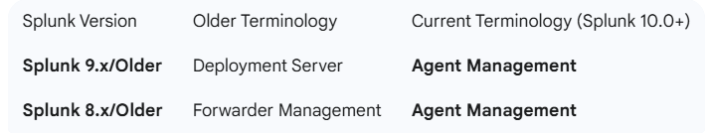

**Note:** If you encounter the terms "Deployment Server" or "Forwarder Management" in older documentation or videos, they refer to the same concept as the current **Agent Management** feature.

===================================================================================

1. **Server Class and Deployment Apps:**

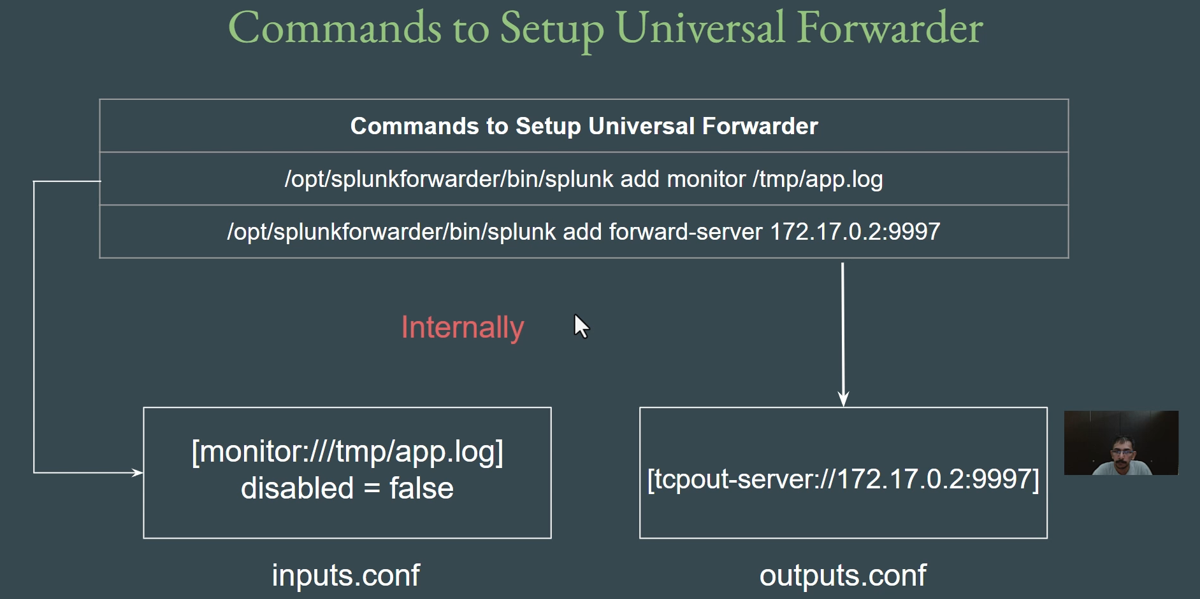

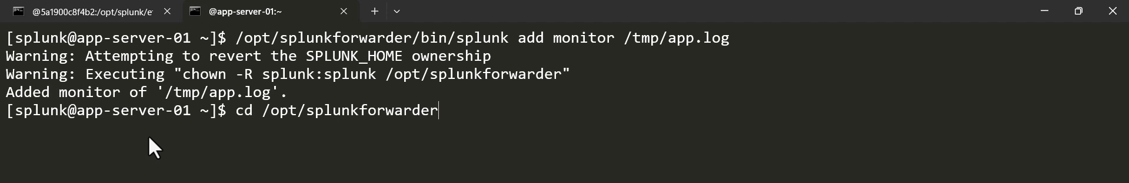

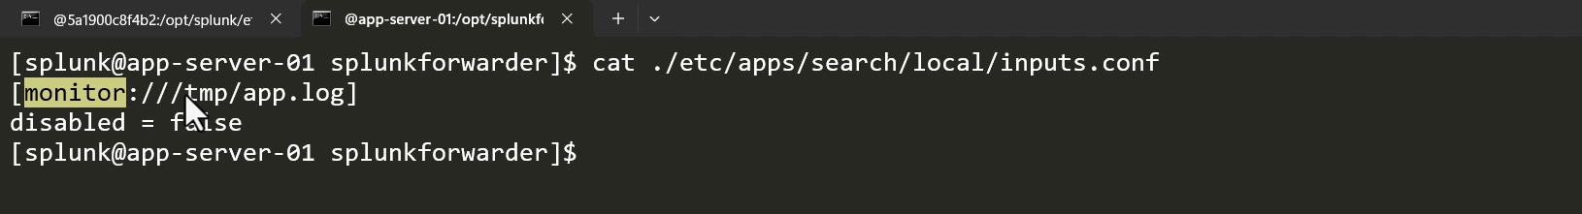

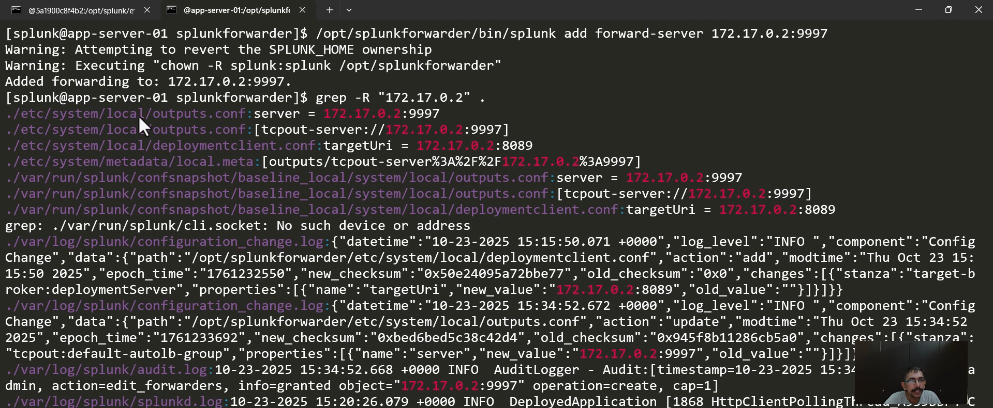

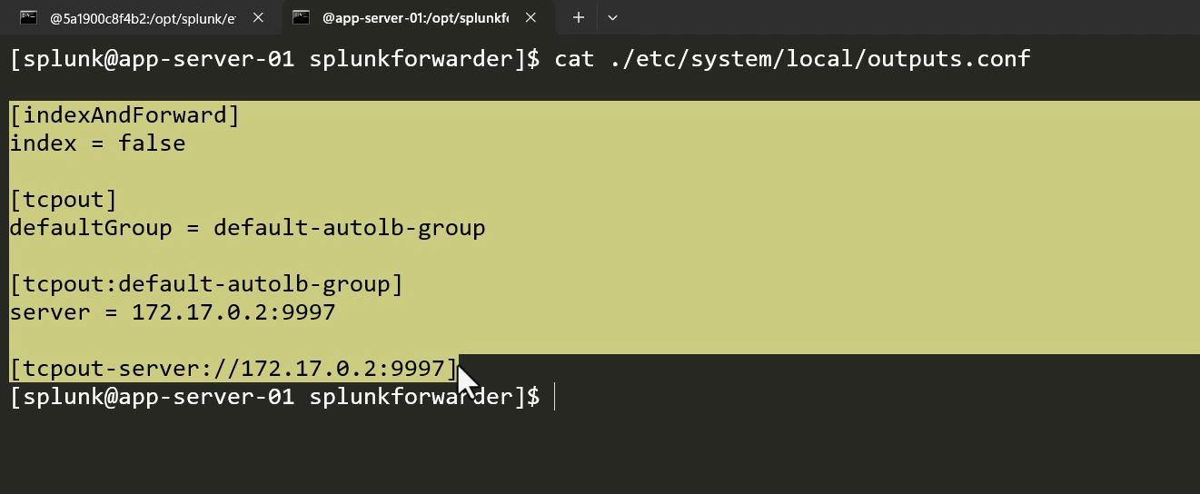

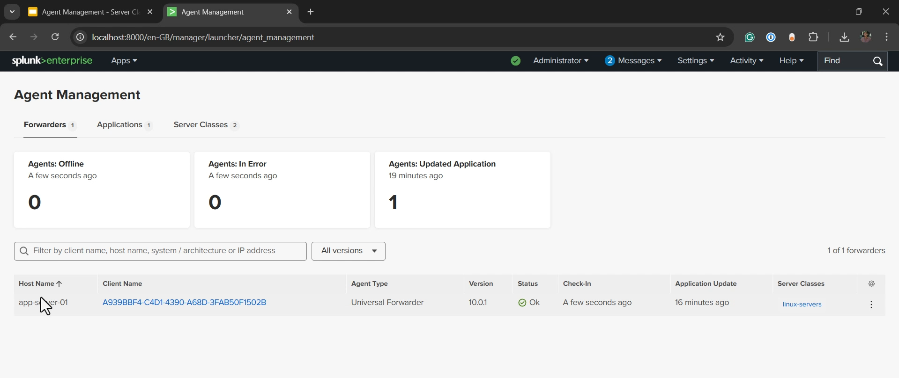

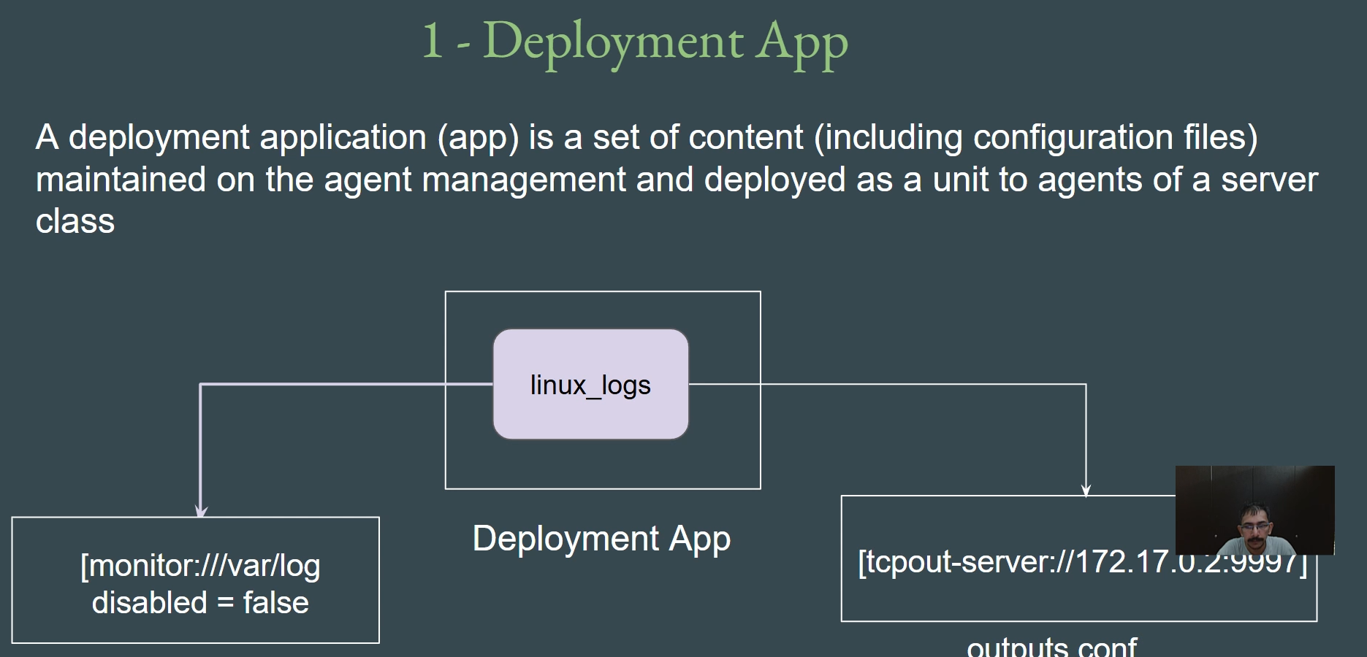

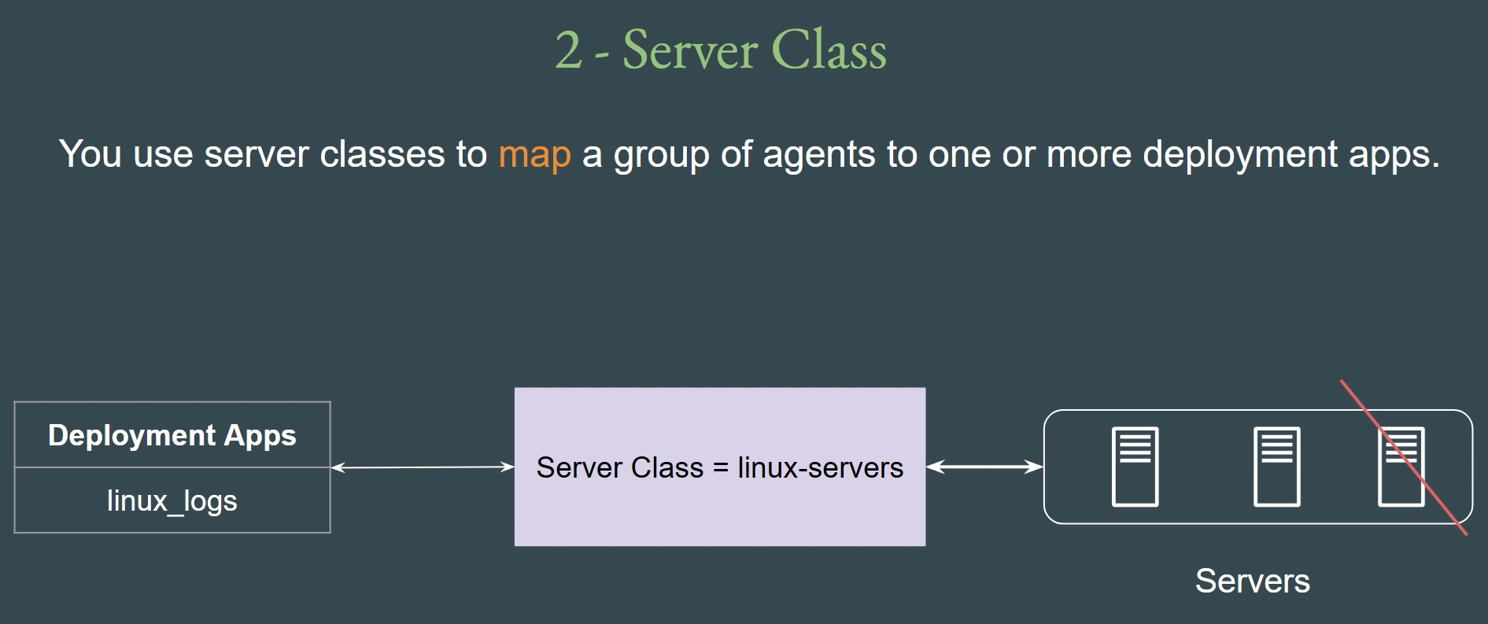

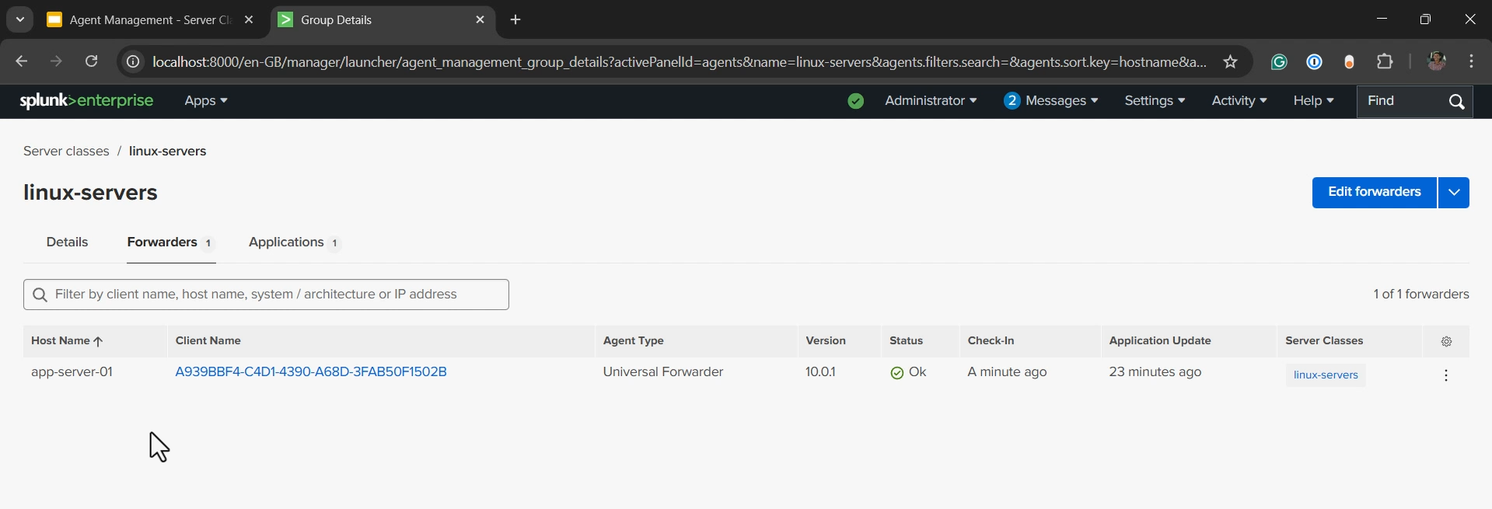

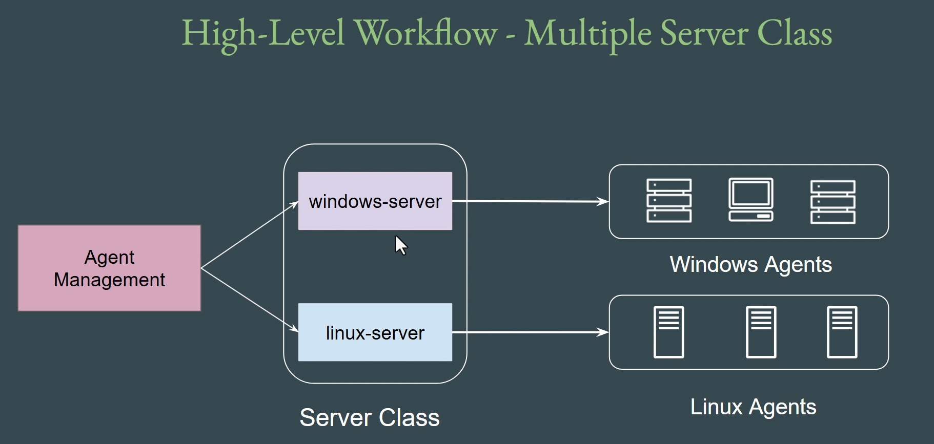

**Agent Management: Server Class & Deployment App**

**1. Internal Configuration Files**

The manual CLI commands run on the Universal Forwarder (UF) translate directly into specific configuration files:

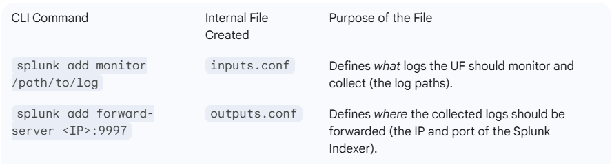

**Key Takeaway:** Agent Management allows you to centrally manage and deploy these critical inputs.conf and outputs.conf files, eliminating the need to run CLI commands or automation scripts on thousands of individual forwarders.

**2. The Deployment Application (Deployment App)**

* **Definition:** A Deployment App (or Application) is a **set of content** or a **configuration package** maintained centrally on the Agent Management Server (Deployment Server).
* **Content:** It primarily contains the configuration files required by the Universal Forwarder, such as:
  + **inputs.conf:** Specifies which logs to monitor (e.g., monitor:///var/log).
  + **outputs.conf:** Specifies the destination Indexer (e.g., defaultGroup = 10.1.1.5:9997).
  + *Note:* The app can contain other configuration files, but inputs.conf and outputs.conf are core for log collection.
* **Function:** This app is the "payload" that will be pushed to a group of forwarders.

**3. The Server Class**

* **Definition:** A Server Class acts as the **mapping engine** or filter used to associate a group of agents (forwarders) with one or more specific Deployment Apps.
* **Function (Map):** It connects the **Deployment App** (the configuration package) to the targeted **Forwarder Agents** (the endpoints).
* **Filtering (Flexibility):** A Server Class uses **filters** to define which agents belong to it, providing high flexibility:
  + **Hostname:** (e.g., win* for Windows machines).
  + **IP Address:** (e.g., 10.5.*.* for a specific data center).
  + **DNS Name, Machine Type**, etc.
  + *Example:* A Server Class named "Linux Servers" can be configured to only include agents whose host property contains "linux" and will only deploy the "Linux Logs" app.

**4. Central Deployment Workflow**

The centralized configuration and deployment process is as follows:

1. **Create Deployment App:** Create an application package (e.g., Linux_Logs) containing the necessary inputs.conf and outputs.conf.
2. **Define Server Class:** Create a Server Class (e.g., Linux Servers) and define the filters to include only the desired agents (e.g., all Linux UFs).
3. **Associate:** **Associate** the Linux_Logs Deployment App with the Linux Servers Server Class.
4. **Deployment:** The Agent Management Server automatically pushes the Linux_Logs app to all forwarders matching the Linux Servers filter.
5. **Agent Action:** The UF receives the app, places the configuration files in its local etc/apps directory, and immediately begins forwarding the new logs to the defined Indexer.
6. **Removal:** To stop monitoring, the app is simply **dissociated** (removed) from the Server Class, and the Agent Management Server pulls the app from the forwarders.

===================================================================================

1. **Practical – Agent Management:**

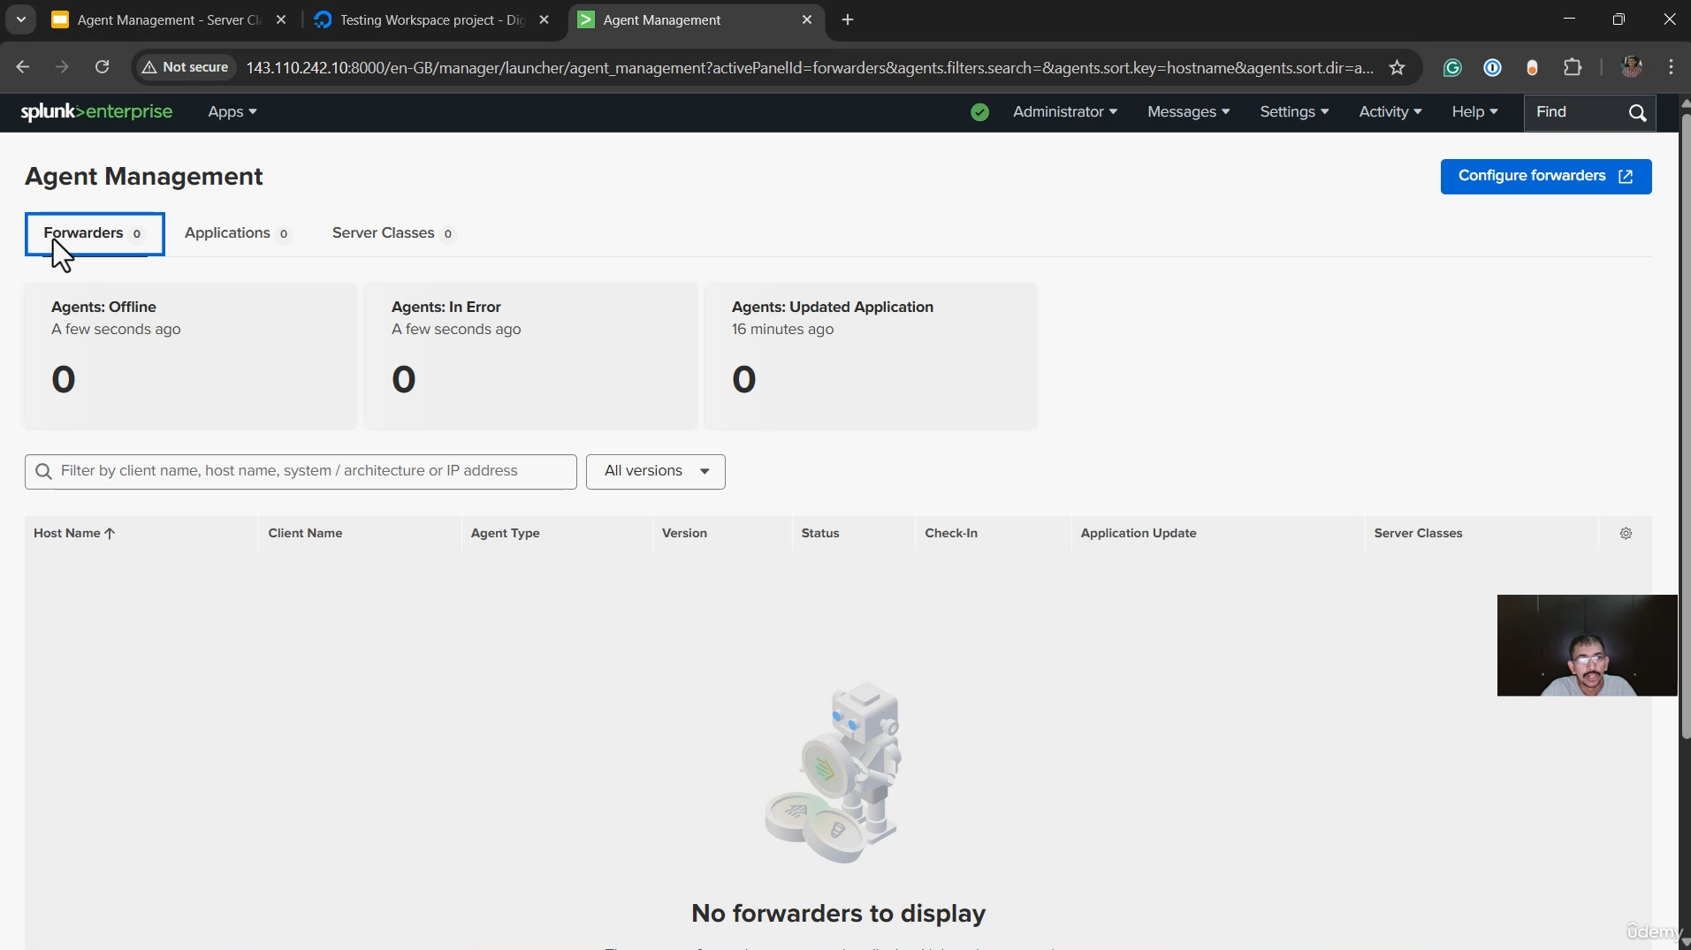

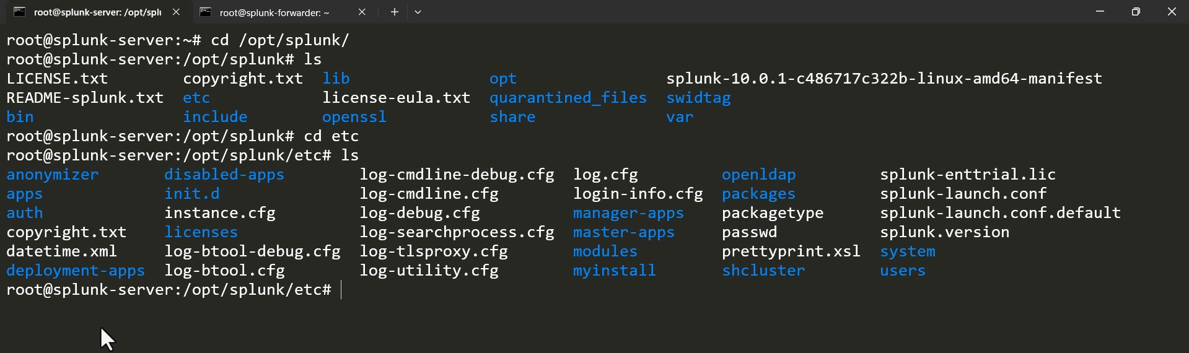

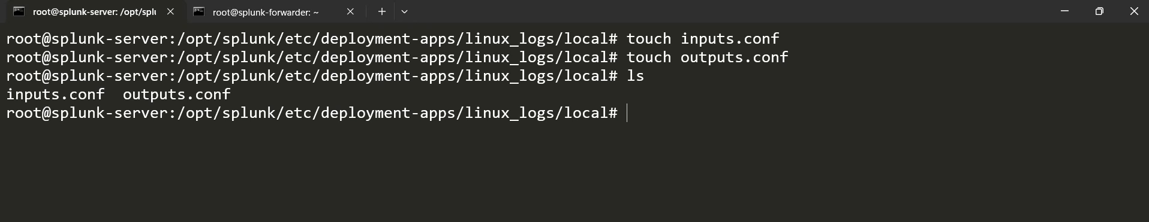

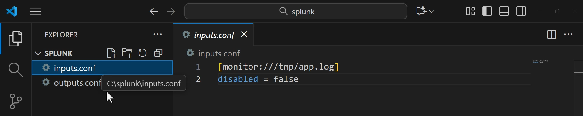

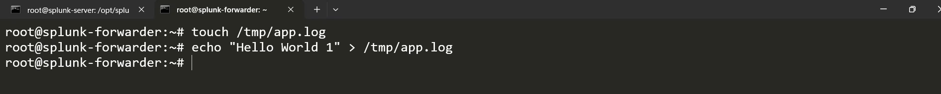

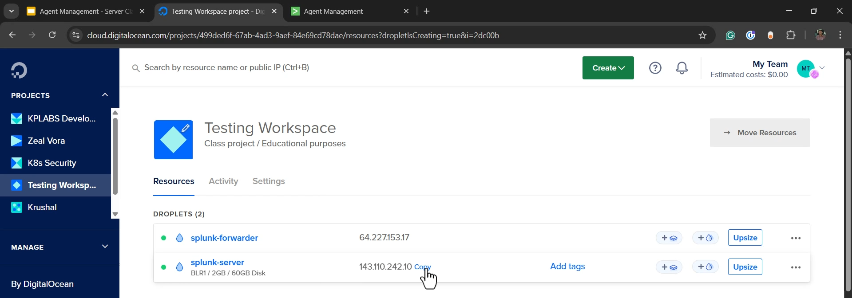

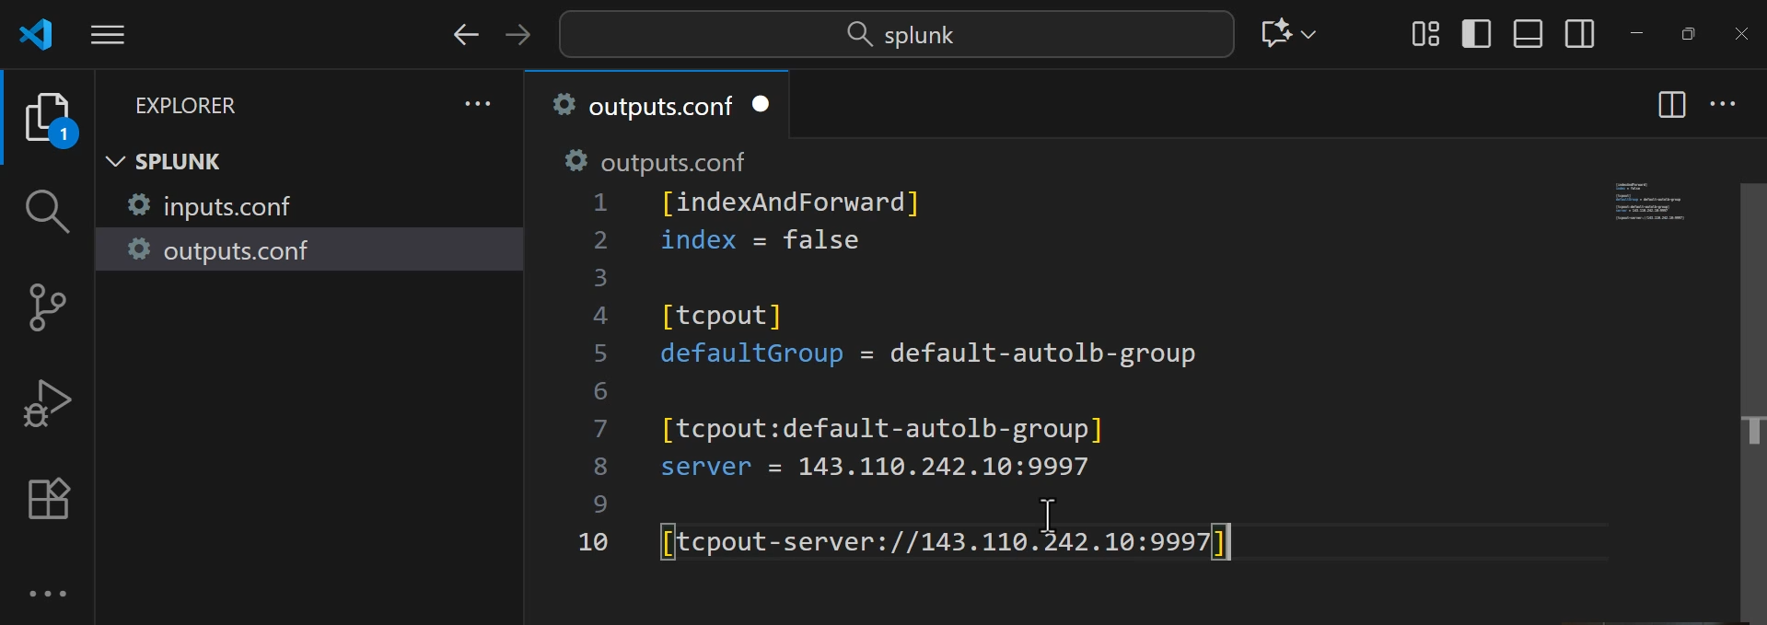

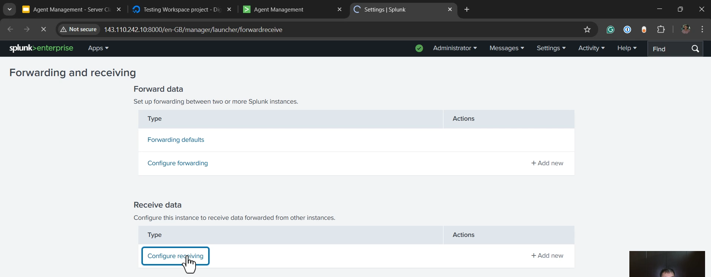

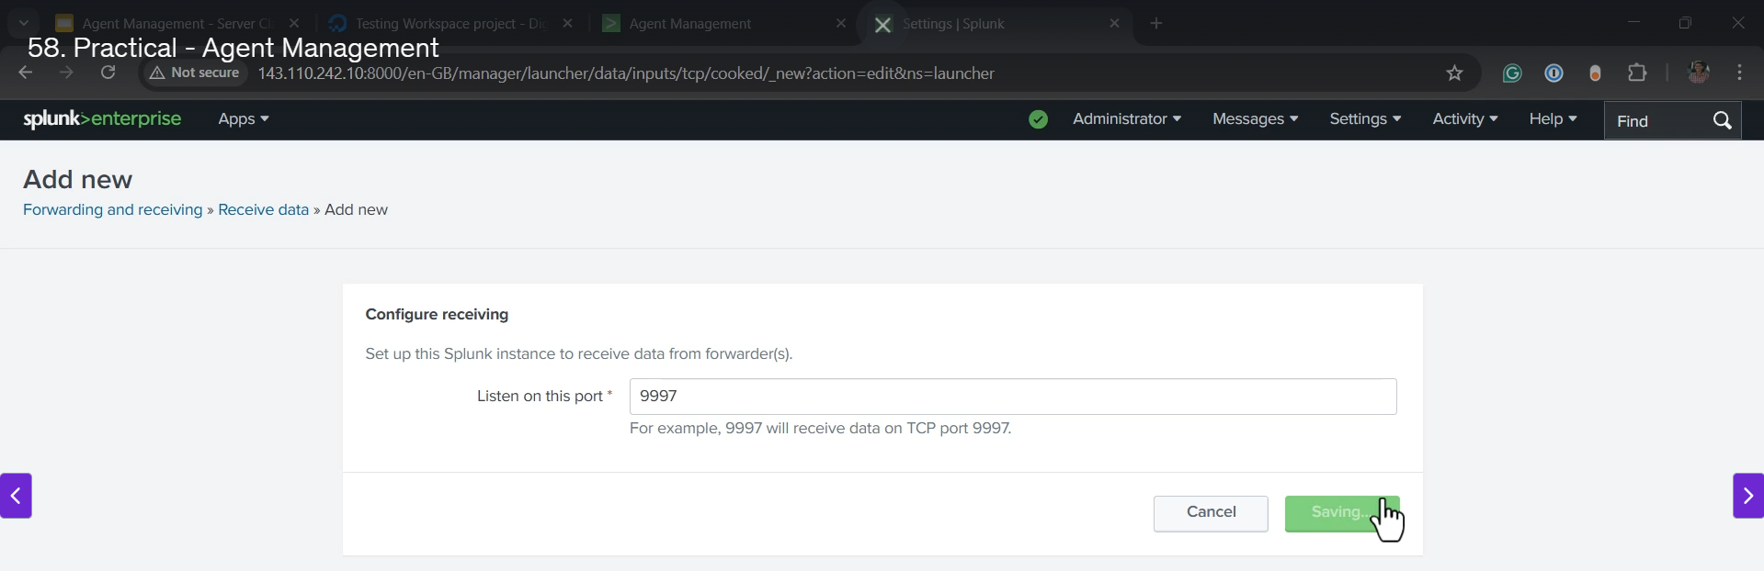

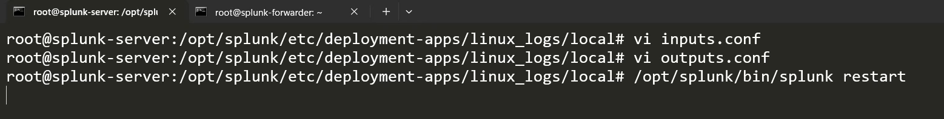

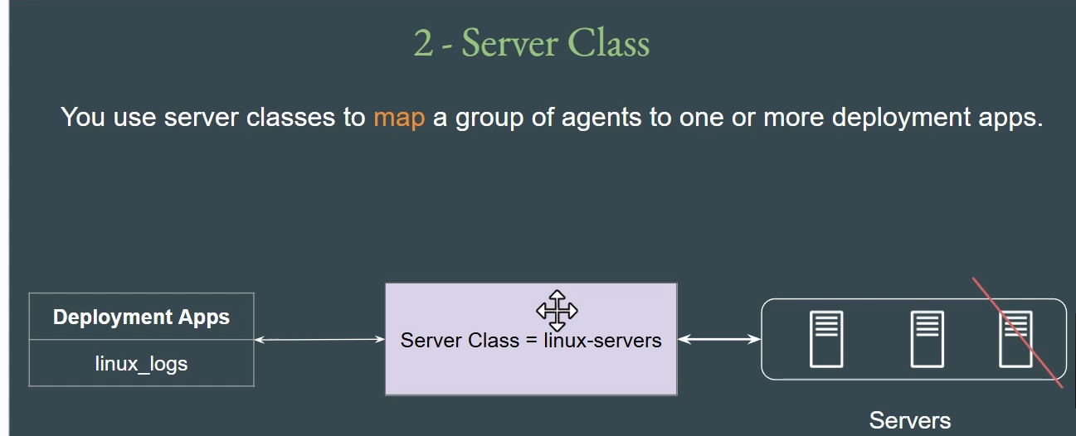

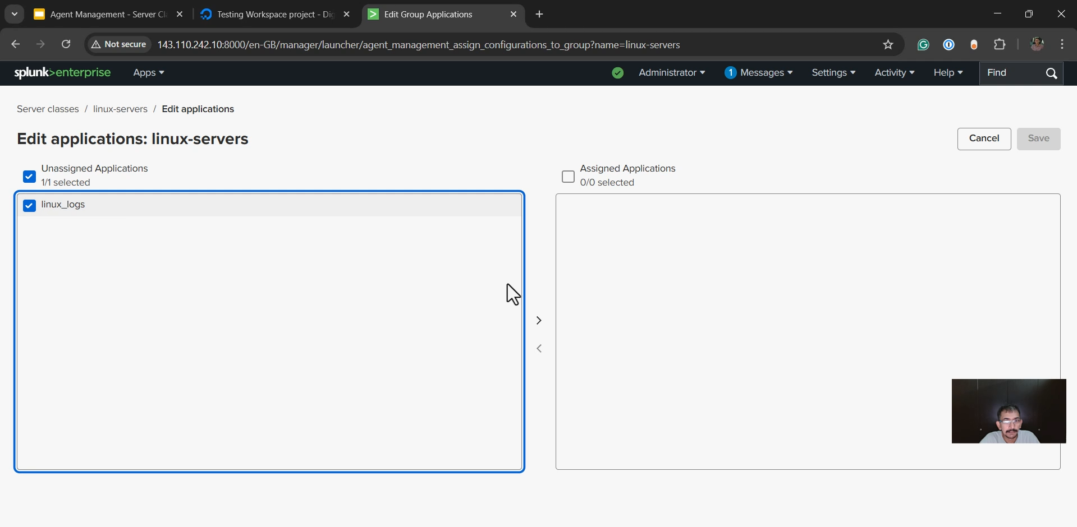

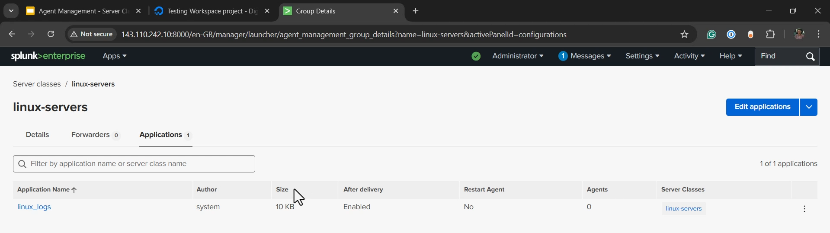

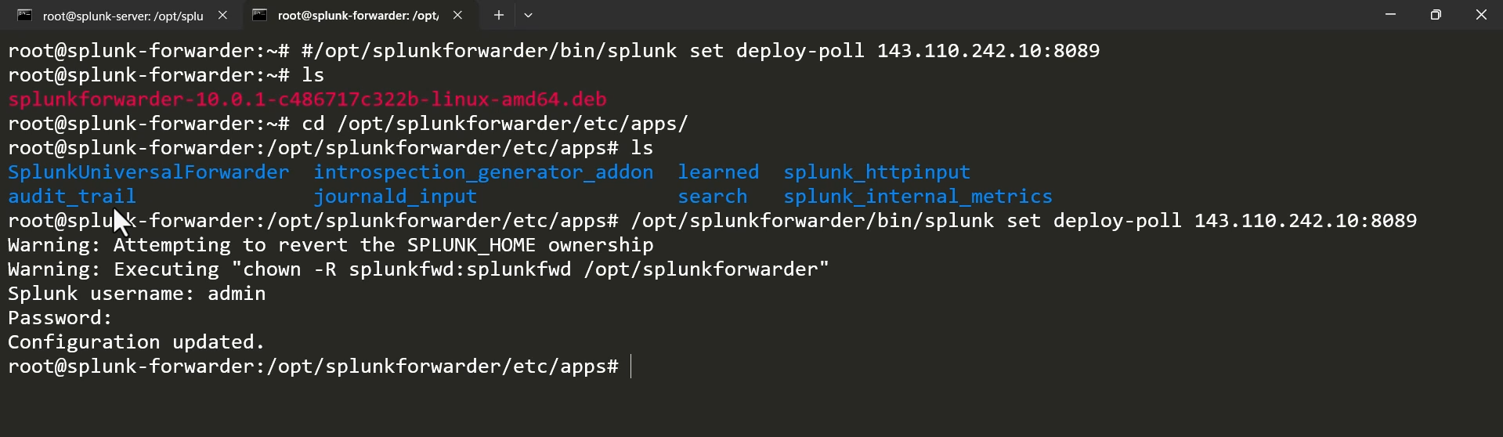

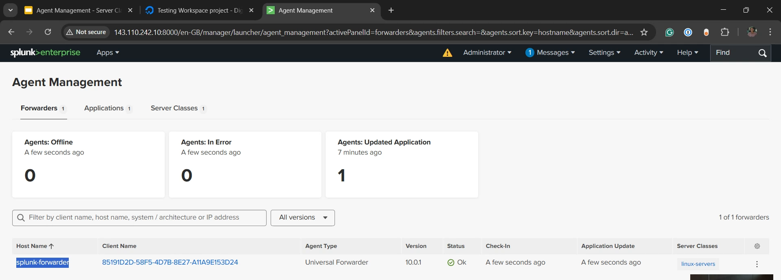

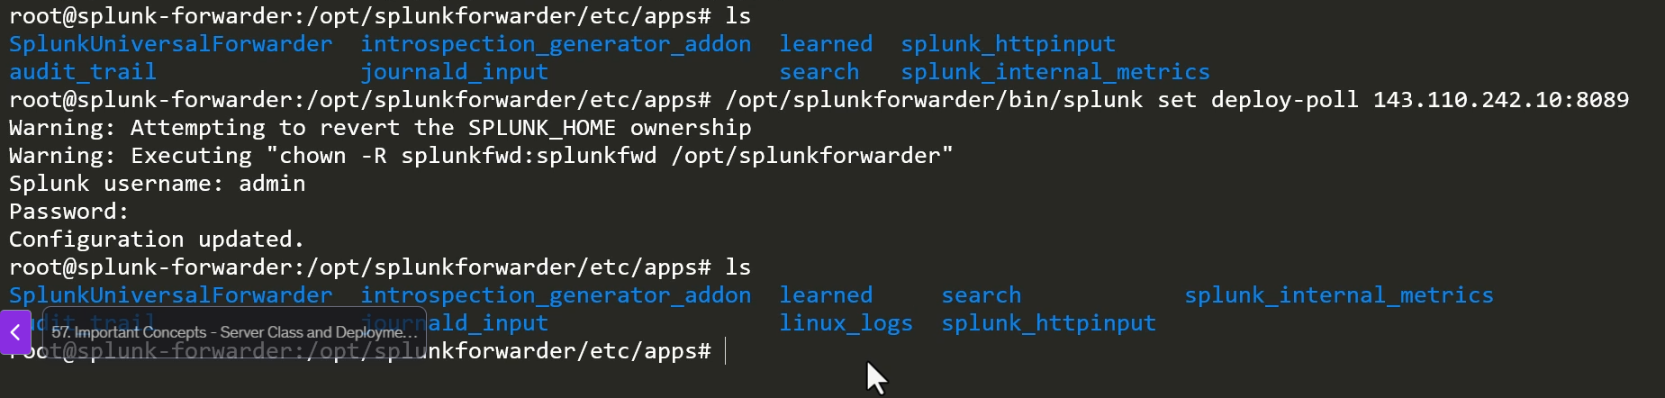

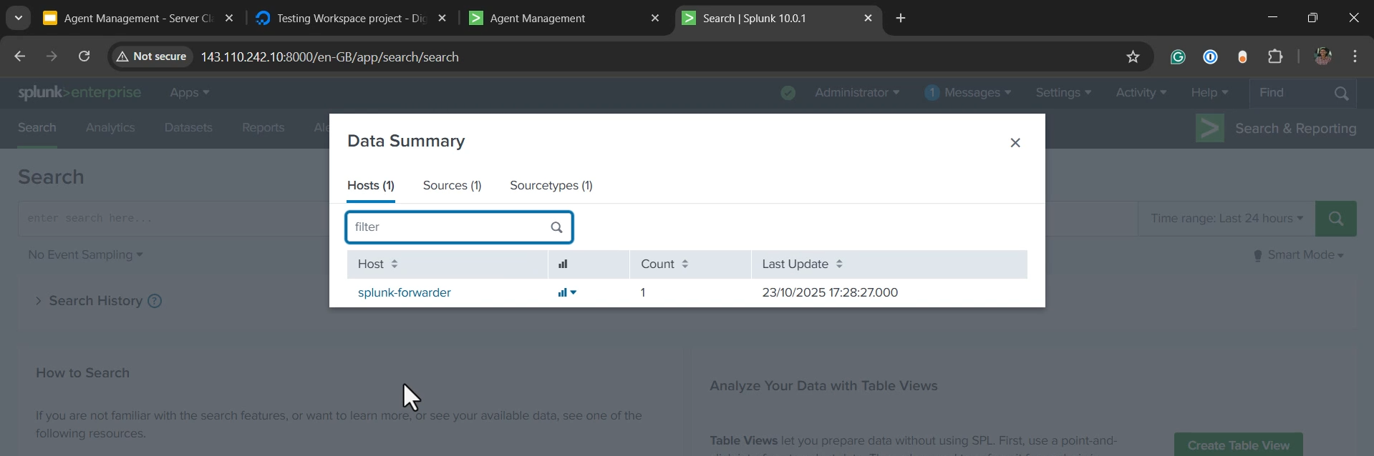

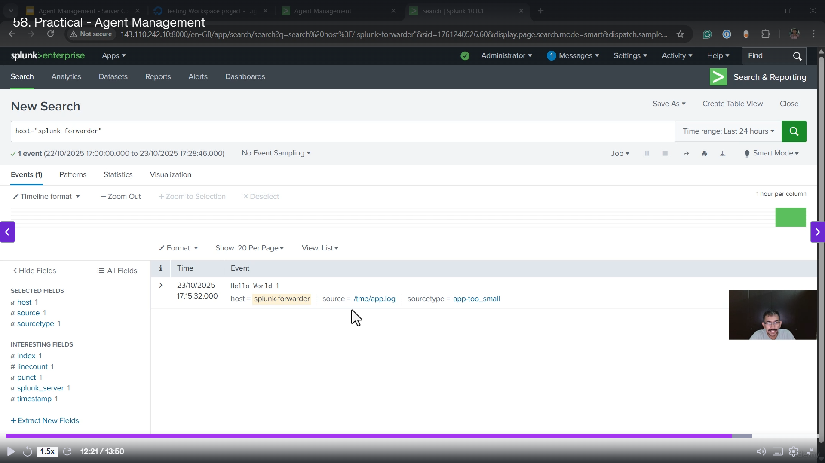

**Practical: Splunk Agent Management Setup**

The video provides a practical, step-by-step demonstration of configuring **Splunk Agent Management** using a Splunk Enterprise server and a Universal Forwarder (UF) instance.

**1. Initial Setup and Environment**

* **Servers Used:**
  + **Splunk Enterprise Instance:** The main Splunk server for indexing and deployment management.
  + **Splunk Forwarder Instance:** A server where the **Universal Forwarder (UF)** is installed and running.
* **Starting State:** The Splunk Enterprise Agent Management dashboard initially shows **zero** forwarders, applications, and server classes.
* **Goal:** To establish a connection where the UF forwards a specific log file to the main Splunk server via a deployed app.

**2. Splunk Deployment Architecture**

* **Hierarchy:** The overall architecture flows as: **Forwarders** $\rightarrow$ **Server Class** $\rightarrow$ **Deployment Apps**.
* **Deployment Apps:** Reside on the **main Splunk Enterprise server** (not the forwarder).
* **Core Components:** Deployment apps contain the configuration files:
  + inputs.conf (What to monitor on the UF).
  + outputs.conf (Where to forward the data).

**3. Creating the Deployment App**

* **Location:** The app is created on the main Splunk server in the path: opt/splunk/etc/deployment-apps/.
* **App Name:** A new deployment app named **Linux_Logs** was created.
* **Configuration Files:** Inside the app folder (Linux_Logs/local/), two files were created:
  + **inputs.conf:** Configured to monitor a file named /tmp/tmp_app.log on the forwarder.
  + **outputs.conf:** Configured to forward logs to the main Splunk instance's IP address on the receiving port **9997**.

**4. Configuring Splunk Enterprise Receiving**

* **Prerequisite:** The main Splunk Enterprise server must be configured to **receive data** on port **9997**.
* **Action:** The port **9997** was manually added and opened in **Settings** $\rightarrow$ **Forwarding and Receiving** $\rightarrow$ **Configure receiving**.

**5. Restarting Splunk Enterprise**

* After creating the deployment app on the Splunk server, the Splunk Enterprise instance was restarted using opt/splunk/bin/splunk restart to load the new app.

**6. Configuring the Server Class**

* **Creation:** A new server class named **Linux Servers** was created in Agent Management.
* **Mapping:** The server class acts as a link between forwarders and apps.
  + **Application Assignment:** The **Linux_Logs** app was included in the Linux Servers class.
  + **Forwarder Assignment:** A **wildcard** (*) was used to assign **all connecting forwarders** to the Linux Servers class for simplicity.

**7. Connecting the Universal Forwarder (UF)**

* **Key Command:** The UF is connected to the Deployment Server using the command:

Bash

opt/splunkforwarder/bin/splunk set deploy-poll <Splunk_Server_IP>:8089

(Note: Port **8089** is the default Management Port used for deployment communication).

* **Result:**
  + The UF immediately connects to the Deployment Server.
  + After a short wait (a few minutes), the UF appears in the Splunk Enterprise Agent Management dashboard.
  + The **Linux_Logs** app is **successfully deployed** to the forwarder, verified by checking the UF's app folder.

**8. Troubleshooting and Final Data Check**

* **Issue:** After app deployment, the log data did not immediately appear in **Data Summary** on the main Splunk server.
* **Solution (Manual Restart):** A manual restart of the **Universal Forwarder** (opt/splunkforwarder/bin/splunk restart) was performed to apply the new configurations (the inputs.conf and outputs.conf).
* **Final Verification:** After the UF restart, the log data (**"Hello World"**) from the /tmp/tmp_app.log file successfully appeared in the Splunk Enterprise **Data Summary**.

**9. Best Practice: Automated Restart**

* **Key Feature:** To avoid manual restarts, the deployment app configuration includes an option called **"Restart Agent"**.
* **Recommendation:** This feature should be **enabled** in a production environment so that any time an app is updated or deployed, the Universal Forwarder automatically restarts to apply the new changes. This maintains the hands-off, centralized management benefit of the Deployment Server.

******************************************************************************************************************************************************************************************************************************************************************************************